CAPITAL AREA PURCHASING ASSOCIATION
(CAPA)

Standard Operating
Procedures Manual

PURPOSE
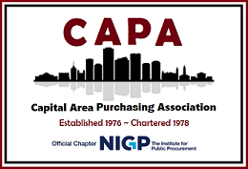

The purpose of this manual is to provide this Chapter, Capital Area Purchasing Association (CAPA), Board of Directors and the CAPA membership a guide for the standard operation of the association relative to the established CAPA Constitution and Bylaws. This manual does not serve to replace or reiterate the Constitution and Bylaws, but rather aids with the succession of the Board and CAPA by outlining the essential, baseline responsibilities which must be performed throughout the year.

Addendums to this manual are made by a majority vote of the Board of Directors and will be noted as a revision to this manual and will include the date of the revision.

CAPA members may submit suggested changes or improvements to the CAPA Board members or email to info@capavirginia.org .
HISTORY
The Capital Area Purchasing Association first commenced in 1976, but did not become a Formal Provisional Charter for the Richmond Metropolitan Area until March 21, 1978. The name of this Association is also known as CAPA. Currently, CAPA is considered a large chapter as defined by NIGP guidelines. The membership consists of procurement professionals within Virginia and continually grows yearly.
CAPA is a chapter of the National Institute of Governmental Purchasing, Inc. (NIGP); a Formal Petition was accepted and approved. CAPA is subject to all Rules and Regulations promulgated by the Board of Directors of the NIGP.
MISSION STATEMENT
Promote and Enhance Professionalism and Education in Public Sector Procurement and Supply Chain Management.
OBJECTIVES
The objectives of this Association are to:
- Establish cooperative relationships among members for the development of efficient purchasing methods and practices in the field of educational, governmental and public institutional procurement.
- Encourage maintenance of ethical standards in buying and selling;
- Promote uniform public purchasing laws and simplified standards and specifications;
- Collect and disseminate useful information for its members;
- Promote the interchange of ideas and experiences within purchasing profession;
- Encourage research and investigation and sponsor such other activities as may be useful in providing its members with knowledge for efficient procurement;
- Strive by all legitimate means to advance the purchasing profession;
- Promote professionalism in public purchasing through continuing education.
TABLE OF CONTENTS

Chapter 1: BOARD OF DIRECTORS PAGE 7
President Page 8
Vice-President Page 8
Treasurer Page 9
Secretary Page 9
First-Past President Page 10
Registered Agent Page 10
Website Administrator Page 10
Vacancies Page 11
Term of Office Page 11
Quorum Page 11
SOP-Standard Operating Procedure Manual Page 11
Chapter 2: ELECTION OF NEW BOARD MEMBERS PAGE 12
Nominating Committee Page 12
How A Nominee Is Selected Page 12
Criteria for Board Members Page 12
Announcement of Nominees Page 13
October Meeting Announcement Page 13
Electronic Election Process Page 15
Electronic Election Schedule Page 15
How the Electronic Voting Process Works Page 15
Benefits of Electronic Voting Page 15
Installation of Officers Page 16
Oaths of Office Page 16
Annual Plaque(s) Board Members Page 18
Plaque for Outgoing President Page 19
Chapter 3: TYPES OF MEMBERSHIP PAGE 20
Voting Membership Page 20
Honorary Membership Page 20
Student Membership Page 20
Retired Membership Page 20
NIGP Page 20
Non-NIGP Page 20
Chapter 4: NIGP PAGE 21
Region II Page 21
NIGP Code of Ethics Page 22
NIGP Meetings Page 22
NIGP Chapter Academy Page 23 NIGP Annual Conference (Forum) Page 23
NIGP Conference (Forum) Guidelines for CAPA Board Members Page 23
Chapter 5: CODE OF CONDUCT Page 24
Code of Conduct Page 24
Reporting Violations Page 25
Grievance Page 25
Revocation Page 25
TABLE OF CONTENTS CONTINUED
Violations Not Addressed Page 25
Chapter 6: ANNUAL SCHEDULE AND REPORTING PAGE 26
Annual Schedule Page 26
Annual Budget Page 27
Bank Account Page 28
Authorize.net Page 28
NIGP Forms Page 28
NIGP Form Submittal Dates Page 29
Membership Dues and Renewals Page 29
Group and Membership Discounts Page 30
Transfer of Membership Page 30
New Membership Page 30
IRS Forms Page 30
State Corporation Commission Registration Page 30
P. O. Box Renewal Page 30
Chapter 7: EXPENSES PAGE 31
Expense Reimbursements Page 31
Credit Cards Page 31
Credit Card General Policy Page 31
Expense Reporting Page 32
Audit or Review Page 32
Petty Cash Page 32
Deposits Page 32
Updating Member Accounts Page 33
Postage Page 33
Monthly Expenses Page 33
Chapter 8: CAPA COMMITTEES Page 34
Eight Reasons to Join a Committee Page 34
CAPA Committees Page 34
Committee Incentives Page 34
Committee Chairpersons Page 34
The Committee List-Committees Defined Page 36
The Committee List (Table) Page 37
Chapter 9: CAPA BUSINESS MEETINGS PAGE 39
Purchasing Month Page 39
Meeting Schedule Page 39 Meeting Venue Page 40
Cancellation Policy Page 40
Professional Speakers Page 41
Meeting Sponsorship Page 41
Announcements and Registration Page 41
Meeting Roster Page 42
Meeting Agenda Page 42
Parliamentary Procedure Page 42
Standard CAPA Meeting Agenda Page 43
Meeting Minutes Page 44
TABLE OF CONTENTS CONTINUED
Sample of Meeting Minutes Page 45
Treasurer’s Financial Report Page 46
Chapter 10: CAPA WEBSITE PAGE 47
Star chapter Fees Page 47
Domain Fees Page 47
Website Updates Page 47
CAPA Electronic Newsletter Page 47
Announcement and Meeting Emails Page 47
Job Postings Page 48
Education Page 48
Resource Links Page 48
Catalog Page 48
Scheduled Events Page 48
Become a Sponsor Page 48
Member and Non Member Page Page 48
Logo Page 48
Chapter 11: SOCIAL MEDIA AND CAPA FEEDS PAGE 49
Social Media Sites Page 49
CAPA Feeds Page 49
Chapter 12: SCHOLARSHIP PROGRAM PAGE 50
CAPA Education Scholarship Page 50
What Does it Cover? Page 51 What Documents Are Needed? Page 51
Essay Question Requirements Page 51
Scholarship Evaluation Selection Process Page 52
Chapter 13: RECORDS MANAGEMENT PAGE 53
Laptop Security Page 54
Conversion of Material and Electronic Records Page 54
Records Retention Page 54
Records Retention Schedule Page 55
Chapter 14: FALL CONFERENCE AND VENDOR EXPOSITION PAGE 56
FC Venue Contract Page 56
FC Committee Page 57
FC Theme Page 54
FC Pricing Page 57
FC Schedule Page 57
Recertification Forms Page 58
Sponsorship-Donation Paperwork Page 58
Vendor Exposition Page 58
FC Sponsorship Page 59 Checklist for Fall Conference Page 59
Chapter 15: REVERSE TRADE SHOW PAGE 60
Member Support Page 60
Venue Contract Page 60
Agencies Page 60
Vendors Page 61
TABLE OF CONTENTS CONTINUED
Sample Schedule Page 61
Chapter 16: CAPA SALES AND FUNDRAISING PAGE 62
Inventory Storage Page 62 Pricing Page 62
Restock Products Page 62
Online Catalog Page 62
Inventory Report Page 62
Customer Satisfaction Page 62
Fundraising Page 63
Fundraising Ideas Page 63
Chapter 17: STORAGE UNIT: EQUIPMENT AND SUPPLIES PAGE 64 Projection Screen Page 64
Projector Page 64
Presenter Page 64
Laser Pointer Page 64
Adapters Page 64
Printer Page 64
CAPA Sign Page 64
Laptop Page 65
Recorder Page 65
Easels Page 65
Tablecloths Page 65
Photo Frames, Photo Holders (For Vendor Information on Tables) Page 65
Decorations Page 65
Craft Items Page 65
Promotional Items Page 65
Inventory Reporting Page 65
ANNEX SAMPLES OF FORMS Page 66
ANNEX A: Proposed Annual Budget Page 67
ANNEX B: NIGP Chapter Member Reporting Form Page 68
ANNEX C: 990N Postcard Page 69
ANNEX D: SCC E-File Registration Page 70
ANNEX E: Monthly Financial Reporting Page 71
ANNEX F: Financial Reporting-All Accounts Page 72
ANNEX G: Certificate of Attendance Record Page 73
ANNEX H: CAPA Reimbursement Form Page 74
ANNEX I: Meeting Roster Page 75
ANNEX J: Meeting Minute Report Page 76
ANNEX K: Treasurer’s Report Page 77
ANNEX L: Scholarship Application Form Page 78
ANNEX M: Scholarship Essay Questions Page 79
ANNEX N: Fall Conference Schedule Page 81
ANNEX O: Sponsorship Levels Page 82
ANNEX P: Sponsor Donation Form Page 83
MANUAL VERSION HISTORY PAGE 84

CHAPTER 1 – BOARD OF DIRECTORS

The Board consists of the President, Vice-President, Treasurer, Secretary and the First Past President, which follows in this order, the President governs CAPA during their term; the term of each position is one (1) calendar year beginning January 1st, ending December 31st.

The Board of Directors is selected from a group of diverse individuals who:

- Are able to demonstrate a strong interest in volunteering and public service;
- Can offer the membership their knowledge with financial & personnel management, organizational strategy, and other professional skills;
- Expose the membership to a variety of personalities.

The Board of Directors shall render advice, carry on needed activities, make any emergency or assigned decisions required, manage the affairs of the Association, and shall have authority to take such actions as will best serve the interests of the Association and its members. Duties are outlined in this manual.

No member of this Association shall be considered for President, Vice President or Treasurer unless the member holds an agency or individual membership with NIGP and has been a member in good standing* for at least one year immediately preceding the election. *Good Standing (A member is in good standing if dues are current, no past due balances are on their account and no complaints or unresolved issues within the membership). The Secretary does not have to be a member of NIGP to fill this position, but must obtain their NIGP membership within one (1) year of their term in order to move into the Treasurer or other open vacant positions.

No more than two (2) members from the same organization may be elected to hold office as an immediate Board member (President, Vice President, Treasurer or Secretary) at the same time, unless this situation becomes the result of a change in employment.

Board members shall be elected annually at the November meeting from a slate of candidates, (generally the current elected Board transferring positions), presented by a nominating committee or any eligible members nominated from the floor. The majority of votes received for that individual will be determining factor for a candidate to win election.

All Members of the Board shall be required to perform his or her duties, including serve as a member on any committee if needed. Follow the By Laws, State Laws, Policies and Procedures of the Organization as adopted by the Board Directors.

The Board members shall have an understanding that the position has a requirement of one (1) year Commitment to the Board.

The Board cannot allow the Chapter, Board or Membership to mismanage or abuse funds or allow the Chapter to go into debt. Chapter Account information shall be readily available to all members of the Board at their request.

(Reference NIGP Code of Ethics Chapter 4 and CAPA Code of Conduct, Chapter 5).
PRESIDENT
Consistent with the CAPA Constitution and Bylaws, the President governs all actions performed by, or on behalf of CAPA, authorizes expenditures, provides a written agenda, is informed of all communication involving CAPA affairs and signs all documents that require the President’s signature.
The following is a summary of the recurring duties of President and may not depict all:
- Present a Proposed Annual Budget (Ref. Annex A) to the Members for Approval in January;
- Complete and Submit the Annual NIGP Chapter Member Data Reporting Form (Ref. Annex B). that are emailed as a link or can be found on the NIGP website ;
- Participate in NIGP Meetings either by phone or in person;
- Ensure completion of 990-N Postcard and SCC Registration and all Required Yearly Submissions and Renewals before Due Date (Ref. Annex C & D) submitted by the President or Registered agent;
- Shall hold at a minimum Quarterly Board Meetings (e.g. January, April, July, October and December) or Board can meet as often as necessary;
- Business Meeting Events Secure a venue; obtain a speaker/presenter; Distribute meeting announcements to Members, work with sponsorship committee to solicit sponsors for meetings;
- Communicate to all Board Members status on financials, events, projects, members, and other information pertinent to CAPA;
- Encourage CAPA Members to become Volunteers on CAPA Committees ;
- Coordinate with VAGP for Governor declaration making March as Purchasing Month ;
- Collaborate with CAPA volunteers or RTS committee for Reverse Trade Show ;
- May Attend the NIGP Annual Conference/Forum if budgetary constraints allow.
The President may assign other duties as needed to the Board and Committee members.
VICE-PRESIDENT
Vice President will work to establish CAPA goals and mission and duties as assigned by the President. In the absence of, or as requested by the President, the Vice-President shall assume responsibility for governing the affairs of CAPA as stipulated in the CAPA Constitution and Bylaws.
The following is a summary of the recurring duties of the Vice-President and may not depict all:
- Is responsible for managing the Conference and coordinating the Committee for the Annual CAPA Fall Conference and Vendor Exposition (Ref. Chapter 14) and other venues as request by President;
- Serves as President elect if President is unable to perform their duties or is unavailable;
- Assumes the Duties of the President in the event the President is unable to fulfill those duties, or if the position of President becomes vacant;
- Is required to Sign for Reimbursement Expenditures for CAPA members over $500;
- Will Preside Over Meetings in the absence of the President or on behalf of the President per the President’s approval;
- In the absence of the Treasurer, the Vice-President will Perform the Duties of the Treasurer.
- Will Oversee Committee(s) As Appointed By The President To Ensure They Are Meeting Regularly And Presenting Committee Reports And Updates;
- May Attend the NIGP Annual Conference/Forum if budgetary constraints allow. (Ref. Chapter 4) and other Events as requested by President;
TREASURER
The Treasurer maintains accurate documentation of all CAPA financial records and accounts in Star Chapter and with SunTrust; this also includes the invoicing for dues, venue, food, conference, etc.
The following is a comprehensive summary of the recurring duties of the Treasurer and may not depict all:
- Present a Monthly Financial Report (Ref. Annex E & F) to the Members at each business meeting and/or quarterly electronically to all members for each account held at SunTrust;
- Maintains a Complete Record of all receipts and disbursements in a binder and/or electronic file to be filed with record keeper or stored w/files at the end of the year;
- Oversees the Member Registration and Creates a Sign-In Roster for monthly meetings;
- Is responsible for the Collection of Revenue, including the membership dues;
- Provides a report of Delinquent Dues to the Secretary for follow-up;
- Maintains a Petty Cash balance;
- Disseminate a Reminder to Members of Upcoming Yearly Dues to each CAPA member before the end of the month of November either by email, fax or mail;
- Before December 1st , Update the Dues information & Pricing after collaboration with the newly Elected Board Members;
- Deposit all incoming dues and fees promptly, update member records;
- Send Statements to members for Dues, Meeting Fees, Conference, etc. for balances owed;
- Ensure timely Payment of Expenses, including Credit Card payments for vendors, caterers, and pay full amount due on credit cards;
- Performs Bank Reconciliation for physical and electronic transactions monthly.
- Will Oversee Committee(s) As Appointed By The President To Ensure They Are Meeting Regularly And Presenting Committee Reports And Updates;
- May Attend the NIGP Chapter Academy and/or Chapter 2 Regional Conference Representing CAPA if not done prior to position and if budgetary constraints allow. (Ref. Chapter 4) Only allowed one (1) trip to each event per Board Member Term (4 Year).
SECRETARY
The Secretary maintains the meeting minutes, mail, updates member information, verifies attendance, solicits new members for the organization and helps with yearly awards.
The following is a summary of the recurring duties of Secretary and may not depict all:
- Provide written Minutes of the proceedings of all meetings, including Board, monthly business meetings and other meetings of the Board as called. Minutes from the previous meeting are to be distributed at the next CAPA Business meeting. Even if Secretary does not collect the minutes, they are responsible for distribution and filing of the minutes from all CAPA meetings. Post a copy of Meeting Minutes to website after approval by President;
- Follow Up with Members on Delinquent accounts;
- Distribute an accurate Roster Of CAPA Members Registered With CAPA Electronically on or before the December Meeting Requesting Members to Update their Information;
- Provide Verification of Attendance for CAPA members before the end of December;
- Collaborate With Awards Committee For Member Awards before the December meeting;
- Update Members Online Information when requested;
- Pick Up Mail from P.O. Box no less than one (1) time per month and every ten (10) business days during special events;
- Send an Email to all Board members Describing Mail received, all statements, checks and invoices need to be delivered to Treasurer before the end of the month, other mail to the President and junk mail can be discarded (if unsure, do not discard).
- Sends Certificate Of Attendance by Email (Ref.Annex G) To All the Members whom attended a meeting or other event they did not receive a certificate prior, before December 31st.
- Will Oversee Committee(s) As Appointed By The President To Ensure They Are Meeting Regularly And Presenting Committee Reports And Updates;
- May Attend the NIGP Chapter Academy and/or Chapter 2 Regional Conference Representing CAPA if budgetary constraints allow. (Ref. Chapter 4) Only allowed one (1) trip to each event per Board Member Term (4 Year).
FIRST-PAST PRESIDENT
The First Past-President serves as a valuable resource to the Board. Duties of First Past President are as follows and may not depict all:
- Primary Responsibility is to serve as the Chair of the Nominating Committee and the President’s Advisory Council;
- Oversee and verify voting results when elections have been held;
- Be a Guide to current President;
- Specific duties may be assigned by the President as needed.

REGISTERED AGENT
The Registered Agent is an appointed member of the CAPA Board of Directors. Specific duties include the completion of the annual State Corporation Commission registration, and the submission of tax forms to the IRS.
WEBSITE ADMINISTRATOR
The Website Administrator is an appointed Board or CAPA member who maintains the Star Chapter site (CAPA website).
The following is a summary of the recurring duties of Website Administrator and may not depict all:
- Updates Information on Website, Keeps Current;
- Maintains Member And Board Profiles, Job Listings, Class and Other Information When Presented Weekly or as Often as Needed;
- Sends Meeting, Conference, Class, and other Announcements;
- Provides Helpdesk Support to Online Users, Members, Non Members and Guests;
- Performs All The Duties Related To Updating The Website;
- Works with Board to Send Correspondence to Members (includes emails to members, surveys, meeting announcements, etc.).
VACANCIES
If a vacancy occurs in the office of President, Vice President, or Treasurer, the remaining Board Members shall ascend in rank to fill the vacant position until an election can be held. All vacancies shall be filled by election at the earliest possible regular monthly meeting following the occurrence of the vacancy to obtain the majority of Member votes. Elections shall be in accordance with Article I of the Bylaws and the election process. If a Secretary is not in place, the remaining Board members shall assume the duties of Secretary until one can be installed into that position, and this is the same in all vacant positions.
TERM OF OFFICE
The term of Board of Directors shall be based on the calendar year and commence on January 1st and end December 31st, following the Oaths of Office in December. The term of each office shall be a period of one (1) year. The current Board will transition the oncoming Board into their duties by ensuring accounts, information and any pending issues are resolved or updated.
QUORUM
A quorum at a Board meeting shall consist of a majority of the Board of Directors. A quorum at any regular meeting shall consist of a minimum of 10% of the members of the Association at that time. The lack of a quorum at a meeting shall not prevent those in attendance from proceeding with the program of the day.
The part of meeting will not proceed for the electing officers, amending the Bylaws or where a quorum of the memberships vote is required. This will be done during the next meeting (if not immediately imperative) or the request for a Quorum of membership votes will be electronically delivered to acquire the 10% voting requirement.
SOP-STANDARD OPERATING PROCEDURE MANUAL
The Board and Membership shall utilize the CAPA Standard Operating Procedure Manual (SOP) to manage day to day activities. The SOP shall be maintained by the Board and reviewed at a minimum one (1) time a year and as often as necessary. Members may present suggestions to the Board about concerns or changes that need to be reviewed and/or updated.
In instances where an area is not outlined in the SOP, the Board will make the determination as a whole to include a policy or procedure. The SOP is available to the entire membership and accessible by them only and may be found on the website under the Member’s area.
It will be the Board’s responsibility to maintain and post the latest version.
CHAPTER 2 – ELECTION OF NEW BOARD MEMBERS

This chapter details the standard correspondence used to announce nominees for the CAPA Board. Refer to the CAPA Bylaws (Article I: Election of Officers) for guidelines for the election of the Board.

NOMINATING COMMITTEE

Beginning on January 1st, the immediate First Past President will become the Chairperson for the Nominating Committee and this shall follow each year for the next First Past Presidents. The Chair will appoint a committee with no more than three (3) member participants (if applicable), one of which is the Chairperson (First Past President).

HOW A NOMINEE IS SELECTED

At a minimum of two (2) weeks before the scheduled October meeting, the current Board members are offered the opportunity to move forward on the Board, provided that person still meets the criteria for a Board member. If the current Board agrees to move forward the position of Secretary will be open for a candidate. If one (1) or more Board members decline to move forward, that position would open and would ascend in order.

If the Nominating committee receives recommendations from members for candidates, in addition to the current Board members seeking candidacy, the committee shall evaluate the persons being nominated. If approved by the committee and have met the criteria, the names of the individual(s) for the nominees for each Board position shall be named and presented to the President at least three (3) weeks before the October meeting. Candidates may run for any Board of Director position, even if current Board members agree to move up.

Once approved by the current President, the list of nominees is disseminated to the membership electronically no less than seven (7) days before the October monthly meeting. A brief biography of each nominee should be included with the email announcement. No changes in the nominees on the slate may be made after submission to the President except at the request of the nominee; however, additional nominations may be made from the floor at the October meeting if the nominee has given permission to be added to the slate of nominees before the October meeting commences.

CRITERIA FOR BOARD MEMBERS

The following criteria should be adhered to for a candidate being considered for nomination:

- No member shall be considered for President, Vice President or Treasurer unless the member holds an agency or individual membership with NIGP for one (1) year prior to the nomination (if a member loses its membership with NIGP during the term for unforeseen circumstances it will be a determination of majority vote of the members if that Board member shall proceed);
- For Candidates, not current Board members, who are seeking a nomination, it will be a requirement that the individual must have served as a Treasurer, Vice President or President prior with CAPA or with another Chapter (proof will need to be submitted);
- The Secretary shall become or be a CAPA member prior to the nomination for this position on the Board; if the Secretary wishes to move into the next position on the Board, they must become a NIGP registered member individually or through their agency at least one (1) calendar year prior to the next CAPA Board election to be eligible to move into the next position;
- A member is in good standing if dues are current, no past due balances are on their account and no complaints or unresolved issues within the membership;
- The current Board member(s) have participated throughout the prior year in events, classes, promoting the goals of CAPA or has shown their dedication to the members of the Association;
- The Nominee shall have an understanding that the position has a requirement of one (1) year Commitment to the Board.

ANNOUNCEMENT OF NOMINEES
Once approved by the current President, the list of nominees is disseminated to the membership electronically no less than seven (7) days before the October monthly meeting. A brief biography of each nominee should be included with the email announcement.

The following format may be used.

Dear CAPA Members,
The CAPA nominating committee is pleased to present to the membership the proposed slate of Officers for (year). (A biography of each candidate is attached.)
President “Name” “Agency” Current Position or New Nominee

Vice President “Name” “Agency” Current Position or New Nominee

Treasurer “Name” “Agency” Current Position or New Nominee

Secretary “Name” “Agency” Current Position or New Nominee

Respectively submitted by the Nominating Committee:
“Name (Chairperson)”
“Name”
“Name”
___________________________________________________________________
We will accept nominations from the floor at the October Business meeting.
Any individual being nominated from the floor must have agreed to be nominated before being introduced. Nominees must be members in good standing with the Association (A member in good standing shall be one who continues to meet membership criteria, whose dues are current and a member of the National Institute of Governmental Purchasing).
OCTOBER MEETING ANNOUNCEMENT

The CAPA Bylaws allow for nominations from the floor at the October meeting. A member must have given permission before the commencement of the October meeting to be announced as a nominee to the Board.

The following is a summary of what is generally stated to introduce the nominees, and the precursor for members to submit nominations from the floor (Nominating committee must be notified of the nomination before meeting begins).

The CAPA nominating committee is pleased to present to the members the proposed slate of Officers for (year).
President “Name” “Agency” “Current Position or New Nominee”

Vice President “Name” “Agency” “Current Position or New Nominee”

Treasurer “Name” “Agency” “Current Position or New Nominee”

Secretary “Name”“Agency” “Current Position or New Nominee”

Respectively submitted by the Nominating Committee:
“Name (Chairperson)”
“Name”
“Name”
__________________________________________________________________________
We will now accept nominations from the floor.
Any individual being nominated from the floor must have agreed to be nominated before being introduced. Nominees must be members in good standing with the Association. (A member in good standing shall be one who continues to meet membership criteria, whose dues are current and a member of the National Institute of Governmental Purchasing).
Do we have any nominations?
If yes, a bio must be submitted by the end of the day. They will be added to the Slate of Officers and included in the online voting process.
If no, currently nominated slate of officers will be presented via the CAPA online voting process.
We will vote for our (State Year) Board electronically before the November meeting where they will be announced and the installation of the Officers will take place at our December Networking event.
ELECTRONIC ELECTION PROCESS
The CAPA Election is generally performed by way of an electronic survey, which is created in the secured administrative area of the CAPA website (i.e., Star Chapter) which the Nominating Chairperson is accessible to the Nomination Survey.
The survey provides members the names, picture and a brief biography of each nominee or other pertinent information.
ELECTRONIC ELECTION SCHEDULE
TASK | DEADLINE | RESPONSIBLE POSITION
Submit slate of Nominees to President for approval | 2 weeks (minimum) before October Business meeting | Nominating Committee
Announce slate of Nominees to Membership | 7 days before October Business meeting | CAPA President
Nominations from the Floor | On or Before the October Business Meeting Commences | Nominating Committee
Disseminate Electronic Election Ballots to Membership | After October Meeting/Prior to November Business meeting | Web Administrator
Announce Results to Membership | November Meeting | Nominating Committee
Present Oath to New Board Members | December Meeting | Nominating Committee

HOW THE ELECTRONIC VOTING PROCESS WORKS
Nominations from the floor must be submitted on or before the October Business meeting commences. After the submissions at the October meeting, an online voting survey will be sent out electronically to all CAPA members only. The electronic process only allows a member to vote one (1) time and the submissions are completely anonymous to other CAPA members including the Board, with the exclusion of the Nomination Chairperson during the voting process. Voting will be open for a minimum period of seven (7) business days and then it is closed; members must cast their ballots during this time frame. No late submissions will be allowed. The Nomination Committee will verify votes and review any errors.
BENEFITS OF ELECTRONIC VOTING
There are many benefits to electronic voting:
- An electronic record will be stored with the results (used for historical or informational purposes) this is only accessible to the nominated President after elections are closed;
- All current registered CAPA members will have the opportunity to vote (not limited to the persons who attend the monthly Business Meetings);
- Can prevent guests and non-members from placing a vote during the ballot process;
- Minimizes mistakes with paper ballot voting;
- All current registered members have electronic access to the CAPA member website;
- Allows ample time for the members to view the bios of the nominees, no rush decisions;
- Voting can be done privately;
- Members are able to vote 24/7 once presented and until the due date and time;
- Members can only cast one vote per ballot;
- Once a member has submitted their vote, results cannot be altered.

NOTE: This is not a guarantee that technical or other errors cannot occur, but limits the possibilities.

INSTALLATION OF OFFICERS
A majority vote for the candidate and 10% of the membership voting shall be the determining factor for the candidate to win the election for that position. The selected candidates will be announced either during a Business meeting if scheduled or electronically; during the December meeting the installation of Officers will take place.
OATHS OF OFFICE
The Chairperson of the Nominating Committee shall present an oath of office to each new board member at the December Networking Meeting.
The oath of office for each position is carried out as by asking the Vice President Elect, the Treasurer Elect, and the Secretary Elect to step forward.
The First Past President addresses the Oath of Office for the Vice-President, Treasurer and Secretary:
Ask each elected Board Member to step forward and state the following:
Vice President Elect…
“Do you _________ swear or affirm that you will abide by the Code of Ethics, the Aims and Objectives of the National Institute of Governmental Purchasing; that you will faithfully perform the duties of Vice-President of the Capital Area Purchasing Association in accordance with the Bylaws of NIGP and CAPA?
If so, signify by saying I DO.”
Treasurer Elect…
“Do you _________ swear or affirm that you will abide by the Code of Ethics, the Aims and Objectives of the National Institute of Governmental Purchasing; that you will faithfully perform the duties of Vice-President of the Capital Area Purchasing Association in accordance with the Bylaws of NIGP and CAPA?
If so, signify by saying I DO.”
Secretary Elect…
“Do you _________ swear or affirm that you will abide by the Code of Ethics, the Aims and Objectives of the National Institute of Governmental Purchasing; that you will faithfully perform the duties of Vice-President of the Capital Area Purchasing Association in accordance with the Bylaws of NIGP and CAPA?
If so, signify by saying I DO.”

After have been duly elected and on behalf of NIGP and CAPA as a Past President, I hereby install you as officers of the Capital Area Purchasing Association for (State the Year).

Oath of Office for the President:
Ask the President-Elect to come forward…
President Elect…
“Yours is perhaps the office that carries the greatest responsibility and the greatest opportunity to be of service.
You shall be expected to represent the chapter on many and varied occasions. You must always remember to speak, not as an individual, but as President of a respected and important organization in your community.
Members will look to you for inspiration. You will be obligated to preserve peace and harmony among the membership. You will preside over all meetings, devoting whatever time is necessary to prepare an agenda. You are expected to conduct each meeting in an orderly and business-like manner. You should insure that all courtesies are extended to the chapter’s guests and speakers.
It is your responsibility to make sure that your committees are continuously alerted and aware of their responsibilities.
You must receive and pass on information concerning Chapter, Regional and National programs, projects, goals and objectives to the membership. You should insure that all correspondence is handled promptly and correctly.
It is your responsibility to call and hold Executive or Board meetings with regularity in order to determine your organization’s policies and programs. In general, you will do all things within the framework of your capabilities to put to good and constructive use, all things that will benefit CAPA and the National Institute.
Yes, this office requires ability and energy, but the rewards are great. With confidence, I ask you to accept the responsibilities of the office of President.
Do you __________ swear or affirm to accept that responsibility? Please acknowledge by saying. I DO.
After having been duly elected and on behalf of NIGP and CAPA, I hereby install you as the Capital Area Purchasing Association (State the Year) President.

ANNUAL PLAQUE(S) FOR BOARD MEMBERS
The current President will present a plaque to the current Boad members (Vice President, Treasurer, Secretary and First Past President). Up until 2017, only the President has been recognized with a outgoing plaque, even though all the Board members play a role governing the Membership annually. In some cases not all Board members have had the opportunity to serve throughout the Board levels, therefore having nothing to show for time of serving as a Board member with CAPA. Beginning December 2018, each Board member shall be presented a basic plaque with their Board title and year of service:
ROSEWOOD HIGH LUSTER PLAQUE FEATURING A Gold PLATE WITH FLORENTINE BORDER, Product# SUB-G-EP810.
A sample of how the plaque shall read is as follows (wording can be altered if needed by President):
Presented to
“Name + Certifications”
20XX CAPA (Vice President, Treasurer, Secretary and First Past President)
In Appreciation of being a Member of the Board Depicting your
Dedication and Commitment with your Contribution to Upholding the Mission of the
Capital Area Purchasing Association.
“Year/Board Member Title”
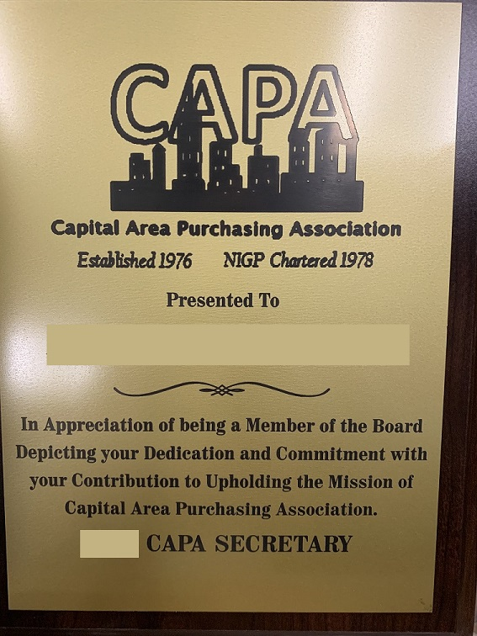

PLAQUE FOR OUTGOING PRESIDENT
The Chairperson of the Nominating Committee presents a 7x9 GAVEL PLAQUE w/ CAPA MEDALLION Product # PG2784 engraved to the outgoing CAPA President during the December meeting.
At this time, Bunkie Trinite Trophies located at 12 E Grace St, Richmond, VA 23219, has the print plates for the CAPA organization and has been servicing the organization since the 1990’s.
The plaque will be read and then presented to the President. Collaborate with the President on the spelling of their name and for certifications. Inquire with the President on their preference of their name to appear on the plaque. The plaque utilizes an older logo established by CAPA, this may be subject to change.
The CAPA Treasurer is responsible for acquiring and delivering the plaque to the Nominating Committee Chair during the December meeting.
A sample of how the plaque shall read is as follows (can be altered if needed):
In Recognition of Your
Service and Commitment
to the
Capital Area Purchasing Association
Presented to
“Name + Certifications”
20XX CAPA President

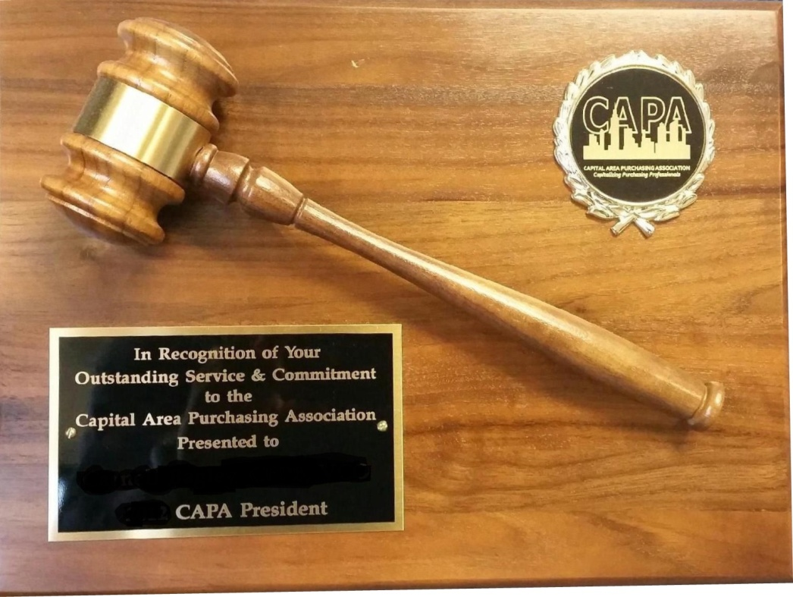

CHAPTER 3 – TYPES OF MEMBERSHIP

Those employed by governmental agencies or subdivisions in the Commonwealth of Virginia whose duties consist in whole or in part of purchasing materials, supplies, apparatus, equipment, contractual services or supplier management are eligible for membership. An Applicant becomes a member upon acceptance of the application and payment of dues and/or, when applicable, approval of the Board of Directors.
There are four categories of the Membership, Voting, Honorary, Student and Retired:
VOTING MEMBERSHIP
Membership in the association shall be open to all public agency procurement and materials management personnel including federal, state, county, municipals and township activities, public school systems, hospitals, commissions, authorities, colleges, universities and other political subdivisions of the Commonwealth of VA. Any person with full time employment in a position having a direct influence on the public procurement process including, but not limited to, staff attorneys, CEO, COO, organizational staff with procurement responsibilities, Finance, department directors, etc. Others may be approved for membership by a majority rule of the Board of Directors.
HONORARY MEMBERSHIP
Honorary membership may be conferred upon individuals who have made distinguished contributions to the purchasing profession or this association by a majority vote of the members present when there is a quorum. Honorary members may serve on committees; but are not entitled to hold office or vote and shall be exempt from payment of chapter dues.
STUDENT MEMBERSHIP
Student membership may be conferred upon college students with an interest in public procurement or who are pursuing a career in public procurement. Students are to furnish proof of enrollment and a copy of their current schedule. Student members may serve on committees but are not entitled to hold office or vote and shall be exempt from payment of chapter dues.
RETIRED MEMBERSHIP
Retired membership may be conferred upon members of the association upon their retirement from the pursuit of their livelihood through active employment, and upon written request for such membership. For purposes of this classification, “retired” shall be defined as retired from a state or local government agency with retirement benefits and neither self-employed nor employed in the private sector in a full-time manner. Retired members may serve as a committee member, but are not entitled to hold office or vote and shall be exempt from payment of chapter dues.
NIGP
Members who are registered as a member with NIGP are offered a discount off the CAPA membership dues which is passed down from NIGP. However, CAPA pays an extra fee to NIGP annually for those members who are not registered NIGP members. When registering, members are asked to choose the appropriate category. NIGP sends a current list of their registered members to CAPA for verification purposes.
NON-NIGP
This type of membership category is when a member is not registered with NIGP as a member or pays NIGP member dues.

CHAPTER 4 – NIGP

Recognized as a Chapter of NIGP, CAPA is subject to all Rules and Regulations promulgated by the Governing Board of the National Institute of Governmental Purchasing, Incorporated (NIGP). In October 2010, the Values and Guiding Principles were finalized and adopted by the NIGP Board of Directors. From that point forward the Values and Guiding Principles began to be adopted by many stakeholder organizations and work on Public Procurement Practices began.

CAPA embraces these Ethics, Values and Principles as an integral sound business practice and conveys trustworthy public purchasing within the Commonwealth of VA. The incorporation of these ideas is deemed an industry best practice. Guiding Principles establish the fundamental norms, rules, or ethics that represent what is desirable (values) and affirmative for our profession and help us determine the rightfulness or wrongfulness of our actions. Principles are more explicit than values, and are meant to govern action.

NIGP’s Values and Guiding Principles of Public Procurement are:
Ethics
- Doing the right thing and acting in a manner true to these values is essential to preserving the public’s trust.
Accountability
- Taking ownership and being responsible to stakeholders for our actions is essential to preserving the public trust and protect the public interest.
Professionalism
- Upholding high standards of job performance and ethical behavior is essential to balancing diverse public interests.
Impartiality
- Unbiased decision-making and action is essential to ensuring fairness for the public good.
Service
- Obligation to assist stakeholders is essential to supporting the public good.
Transparency
- Easily accessible and understandable policies and processes are essential to demonstrating responsible use of public funds.

Although CAPA subscribes to NIGP’s principles and develops partnerships with the National office in the sponsorship of educational seminars, the chapters are legally separate entities. NIGP urges individuals to join your state or local chapter to gain full access to professional development and networking opportunities in your geographical area.

REGION II
CAPA is part of the Region II Area which consists of the following Chapters:
Delaware, Delaware Public Purchasing Association;
District of Columbia, Metropolitan Washington;
Maryland, Maryland Public Purchasing Association;
Pennsylvania, Pennsylvania Public Purchasing Association;
Virginia, Virginia Association of Governmental Purchasing.

NIGP CODE OF ETHICS
NIGP members adhere to the following ethical principles which govern the conduct of every person employed by a public sector procurement or materials management organization:
- Seeks or accepts a position as head (or employee) only when fully in accord with the professional principles applicable thereto and when confident of possessing the qualifications to serve under those principles to the advantage of the employing organization.
- Believes in the dignity and worth of the service rendered by the organization, and the societal responsibilities assumed as a trusted public servant.
- Is governed by the highest ideals of honor and integrity in all public and personal relationships in order to merit the respect and inspire the confidence of the organization and the public being served.
- Believes that personal aggrandizement or personal profit obtained through misuse of public or personal relationships is dishonest and not tolerable.
- Identifies and eliminates participation of any individual in operational situations where a conflict of interest may be involved.
- Believes that members of the Institute and its staff should at no time, or under any circumstances, accept directly or indirectly, gifts, gratuities, or other things of value from suppliers, which might influence or appear to influence purchasing decisions.
- Keeps the governmental organization informed, through appropriate channels, on problems and progress of applicable operations by emphasizing the importance of the facts.
- Resists encroachment on control of personnel in order to preserve integrity as a professional manager.
- Handles all personnel matters on a merit basis, and in compliance with applicable laws prohibiting discrimination in employment on the basis of politics, religion, color, national origin, disability, gender, age, pregnancy and other protected characteristics.
- Seeks or dispenses no personal favors. Handles each administrative problem objectively and empathetically, without discrimination.
- Subscribes to and supports the professional aims and objectives of NIGP - The Institute for Public Procurement.

NIGP MEETINGS

An NIGP Representative holds quarterly teleconferences with Chapter leaders to provide updates and discuss concerns. The CAPA President, or a designated CAPA Board Member, must attend the quarterly teleconferences to ensure CAPA members remain informed. The Board member attending shall relay all information to the other Board members not attending the conference call.

NIGP updates pertinent to the members may be disseminated to the members by way of the CAPA website, at membership meetings and events or by the Board member to the members via email or postings.

NIGP CHAPTER ACADEMY
The Chapter Academy (Leadership Symposium) is not an ordinary leadership experience. It is a journey that leaves an attendee empowered with the knowledge and confidence to lead in ways that will help the Board member transition into a leadership role for the chapter, their agency, their profession, and their Institute.
The Academy is annually held two (2) days in the month of February. This event is open to the Board members of the Chapter or a designated attendee. This is a great opportunity for the individual. The Board at its discretion and if funds are available, may send up to two (2) designated Board or other member.
There is paperwork that can be completed for Chapters who are low in funding to pay for the 1st person or discount the 2nd person. This information can be found on the NIGP website once the Chapter Academy information is posted, or by reaching out to your Chapter Ambassador.
NIGP ANNUAL CONFERENCE

The NIGP Annual Conference and Vendor Exposition is a Forum that is held at different venues throughout the United States and Canada. It is the largest North American educational conference exclusively for individuals in public procurement. This is a once a year opportunity to engage in professional development and network with others in public procurement as well as the supplier community.
The NIGP products exposition provides an opportunity to discover the latest products and services available to the government from a vast array of suppliers. Often, representatives from the major cooperative procurement industry such as AEPA, NJPA or NPPGov are represented at the vendor expo. The educational component of the conference covers the latest hot topics, best practices, resources and skills to help improve job performance and provide professional procurement development.

The CAPA board representatives attending are expected to bring back to the membership information about new trends in the purchasing profession and other pertinent information relative the procurement field to pass along to the members. CAPA urges the membership to attend at least one national conference. Scholarship money may be available to defray the cost of attendance. The conference also offers CEU and recertification points for all sessions.

NIGP CONFERENCE (FORUM) GUIDELINES FOR CAPA BOARD MEMBERS

CAPA strongly supports this NIGP opportunity and supports the CAPA President and Vice-President by allowing them to attend an inclusive paid trip which includes the travel fees for arrival and departure only, (any travel costs incurred during event for travel outside the venue is paid from the Board members funds), lodging at the venue or close to the venue for (1) person only unless Board member is boarding with another CAPA Board or organization Member, and NIGP registration fees to attend the NIGP conference. All food, beverages, travel and miscellaneous that are an additional expense shall be paid by the Board or CAPA Member. If travel is not possible, upon approval by the majority winning vote from the Board members, the Board or CAPA member may use the Virtual Conference feature NIGP offers with CAPA providing funding.

An estimated amount of these expenses must be included in the annual budget but limited if funds are not available in the Associations account at the time of the event to accommodate this opportunity.

All receipts for travel, lodging and the NIGP are to be included with credit card expense sheet or reimbursement form. If receipt is missing and no appropriate documentation included, payment will not be made or must be reimbursed.
CHAPTER 5 – CODE OF CONDUCT

In addition to the NIGP’s Code of Ethics Policy (Ref. Chapter 4, NIGP) CAPA allocates its own Code of Conduct for all affiliates of CAPA to adhere formed from NIGP’s Code of Conduct. A copy of this should be included with sponsorship paperwork, to attendees at CAPA events or to any CAPA member who is a participant representing the organization at other events.
CODE OF CONDUCT
- CAPA is dedicated to providing a safe, friendly, welcoming, and harassment-free environment for all organization members regardless of gender, gender identity or expression, age, sexual orientation, disability, body size, physical appearance, race, ethnicity or religion.
- This Code of Conduct outlines CAPA’s expectations for all members and event participants, including member and non-member attendees, speakers, contractors, exhibitors, sponsors, guests and volunteers. All persons actively participating with CAPA will enforce this code. Cooperation is expected from everyone and CAPA will actively enforce this code throughout the event. Violations are taken seriously.
- The behavior of event and meeting participants are expected to communicate and present themselves in a professional and constructive manner, whether in person or virtually, handle dissent or disagreement with courtesy, dignity and an open mind, be respectful when providing feedback, and be open to alternate points of view. Refrain from demeaning, discriminatory or harassing behavior or speech. CAPA expects all participants to abide by this code of conduct at all events where the individual is a representative of the CAPA organization.
- Unacceptable Behavior by a CAPA representative includes harassment, but is not limited to, offensive verbal or written comments, and negative behavior, whether in person or online, deliberate intimidation, stalking, following, harassing photography or recording, sustained disruption of sessions or other events, inappropriate physical contact, and unwelcome physical contact or sexual attention.
- Other forms of unacceptable behavior are
  - Physical assault or implied threats of physical harm;
  - Real or implied threat of professional or financial damage or harm;
  - Unwelcome and uninvited attention or contact;
  - Possession of a weapon, or that which may cause danger to others if used in a threatening manner;
  - Possession of any open can, bottle or other receptacle containing any alcoholic beverages, except in areas specifically designated for the consumption of alcohol or at events alcohol is offered;
  - Sustained disruption of sessions or other events;
  - Failure to obey the rules and regulations of a venue(s).
- Improper handling of funds or accounts. This includes overspending Budget, excess spending, not reporting expenses or revenues, following spending procedures or other unauthorized purchases.
- Embezzlement or theft of CAPA funds, equipment, supplies, other items of value.
- Any illegal act.
- Misrepresentation of position or title for personal gain.
- Engaging CAPA in a contract that is not beneficial to CAPA and its membership.
REPORTING VIOLATIONS
Violations will be reported to the Board immediately. If possible, provide the following information, preferably in writing:
- Identifying information (name, agency, company, etc.) of the person that was in violation;
- The behavior or incident that was in violation;
- The approximate time and/or date of the behavior/incident (if different than the time/date the report was made);
- The circumstances surrounding the behavior/incident;
- Other people involved in or witnessing the behavior/incident.

Participants violating this code of conduct may be sanctioned or expelled at the discretion of the CAPA Board of Directors, unless the violation is enacted by a Board Member. At that time, the remaining Board members at their discretion, along with membership will be the determining factor. If a CAPA representative, engages in inappropriate, harassing, abusive or destructive behavior or language, the CAPA Board and/or its members, will take the appropriate action against the violator.

- The violation, based on the severity and the CAPA Board deems inappropriate, may result in a verbal warning to the offender;
- Anyone asked to cease any unacceptable behavior is expected to comply immediately;
- Non compliancy may result in removal from an event, without refund of registration fees, and/or banning the offender from future CAPA events and activities;
- Removal from the Membership;
- Immediate action will be decided by the Board and/or its membership;
- Any unlawful behavior will be reported to the appropriate law enforcement organizations.

GRIEVANCE

Any person who feels they have been falsely or unfairly accused of violating this code of conduct should notify the CAPA Board of Directors with a concise description of your grievance within ninety (90) days of the accusation. The Board of Directors will review the grievance and issue a statement indicating the final decision on the matter.

REVOCATION

The Board of Directors may revoke the membership of any person for nonpayment of dues, open balances on their accounts, or for other just cause, including but not limited to violations of the NIGP Code of Ethics or CAPA Code of Conduct. A person considered for membership revocation, except for nonpayment, shall be provided written notice of the proposed action by the Board of Directors and will be given opportunity to show cause as to why the membership should not be revoked.

VIOLATIONS NOT ADDRESSED

Any violation deemed inappropriate that is not defined in the CAPA SOP will be earmarked at that time by the governing Board of Directors.

CHAPTER 6 – ANNUAL SCHEDULE AND REPORTING
This chapter details routine tasks which the CAPA Board must address at the beginning of each term of office. A list of these forms and requirements can be found on the NIGP website under Chapter Resources.
ANNUAL SCHEDULE
BOARD MEMBER | TASK | DATE DUE
President | Prepare Annual Proposed Budget | Present to membership for approval at first meeting of year or in January (approval only if Quorum represented) or send electronically
President | Submit all Required Annual Forms to NIGP (these can be found on the NIGP website). | January 31st ; March 1st , May 15th
President | Ensure financial records & supplies are transferred to New Treasurer | 1st or 2nd week in January
President | Ensure New Secretary can access Member Records | 1st or 2nd week in January
President | Ensure PO Box key is transferred to New Secretary | 1st or 2nd week in January
President | Ensure Bank has signature on file | 1st or 2nd week in January
Vice President | Begin Working on Annual Fall Conference | Immediately following the Current Fall Conference
Vice President | Ensure Bank has signature on file | 1st or 2nd week in January
Treasurer | Pay Domain Fee (if applicable) Domainmonger.com | 1st or 2nd week in January  (Fee is paid in full through 2021)
Treasurer | Login into Authorize.net website (report problems immediately) | 1st or 2nd week in January
Treasurer | Login to Bank Account Website (report problems immediately) | 1st or 2nd week in January
Treasurer | Issue Statement of Dues to Current Members not Paid | 1st or 2nd week in January
Treasurer | Ensure Bank has signature on file | 1st or 2nd week in January
Secretary | Retrieve P.O. Box Renewal Notice, and Mail; Distribute All Monies and Invoices to the Treasurer for payment; Scan other Documents (except Junk) to Board Members (Do not COPY personal information or checks) make note of these and send information to all Board Members | Begin 1st or 2nd week in January
Secretary | Retrieve Key to Post Office box from previous Secretary | Before 1st meeting in January
Registered Agent (ad-hoc member)  Or President | SCC Registration (Sends to SCC with Payment) | March 31st
Registered Agent (ad-hoc member)  Or President | IRS Form 990-N (Sends to IRS ) | May 15th

ANNUAL BUDGET

The President presents an Annual Budget to the Membership for approval at the Business Meeting in January or sends to them electronically for approval. Budget projections are based on the revenue, forecasts and expenses of the previous year.

Listed below are the standard budget items which should be included in the Annual Budget. Additional budget items may be added or deleted based on the President’s desired programs for the year. (Ref. Annex A).
INCOME:
- Monthly Business Meetings
- CAPA Fall Conference/Vendor Expo
- CAPA Reverse Trade Show (If Applicable)
- Educational Courses
- Interest Income
- December Meeting
- Donations
- Sales
- Sponsorships
- Scholarship

EXPENSE:
- Monthly Business Meetings
- CAPA Fall Conference/Vendor Expo
- Educational Courses
- Speaker (Gifts & Stipend)
- December Networking Meeting
- Awards (President plaque & others as desired)
- Website Fees
- NIGP Conference (President & Vice President)
- NIGP Chapter Dues
- PO Box
- Banking Fees
- Promotional Items, Equipment, Supplies
- Scholarship

When the proposed budget is complete, the President shall:

- Meet with the CAPA Board and First Past President to review the proposed budget and make any necessary adjustments;
- Present the Budget to the Membership at the January Business Meeting or Electronically;
- Formally review the proposed budget with the CAPA Members during the January Business Meeting or Post Electronically allowing option for questions (Voting procedures are outlined in the CAPA Constitution and Bylaws);
- Post the Approved Budget to the Treasurer’s report in the Member Area of the CAPA website.

BANK ACCOUNT

CAPA maintains its credit card program and two checking accounts (one for general operation and the other for the Scholarship account) at SunTrust Bank. During the first two weeks of January, all newly elected Board Members are required to visit the bank to obtain signature authorization, account access and to apply for a credit card.

The names of former board members or members no longer in office are removed from the account. For validation purposes, the First-Past President, President and new and former Treasurer should accompany the new Board member(s) to the bank.

The President must ensure that the new Treasurer receives the following from the outgoing Treasurer:
  - Checkbook
  - Master Debit/Credit Card
  - Receipt Book
  - Login Access for Online Banking, SunTrust
  - Login Access and Account Updates for Authorize.net
  - Electronic Bank Records, to include Monthly Treasurer Reports

Note: Account ID’s and Passwords do not get changed unless all Board members are notified of the changes along with new ID’s and Passwords. The information should be changed every term.

AUTHORIZE. NET
Authorize.net is the secure credit card portal for payments made through the CAPA website. The CAPA website accepts credit card payments (with the exception of American Express) at www.capavirginia.org for the purchase of class registrations and chapter merchandise. The service is provided by Authorize.net. The President must ensure that account information is updated in January so the incoming CAPA Treasurer is notified when transactions are made.
For each transaction, Authorize.net emails the CAPA Treasurer at Treasurer@capavirginia.org with notification of the purchase. In addition, the Treasurer receives a daily email which summarizes the charges for the day.
If a credit card needs to be refunded, this would be done through the Authorize.net site under the tools tab or transaction detail tab. To issue a refund you must know the transaction date and dollar amount. The CAPA website does not automatically update, you will have to manually enter the information. It is the same with the CAPA website, it will not process a refund, and it will have to be done through Authorize.net.
The link for Authorize.net is http://www.authorize.net .

The CAPA President, Vice-President and Treasurer will maintain login access for Authorize.net for backup purposes and to view transactions when necessary.

NIGP FORMS

The President is required to submit the following forms electronically to NIGP. Each form is available online at the NIGP Chapter Resource website http://www.nigp.org or is emailed to the President prior to the due dates. Submissions must be completed by the due date listed or CAPA may be penalized.

NIGP FORM SUBMITTAL DATES
Title | Purpose | Due Date
Chapter Officer Form | Provides NIGP the names of new Chapter Officers | January 31st
Chapter Member Data Form | Documents the number of CAPA members, with a distinction of how many are members of NIGP. NIGP uses the data to bill CAPA for annual chapter fees. An updated Member Roster is obtained from the CAPA Treasurer to include with the submission. | January 31st
Chapter Seminar Agreement Form | Grants CAPA the authority to voluntarily host an NIGP Seminar during the year | January 31st
Group Exemption Update Form | Authorizes CAPA to be included in NIGP’s Group Exemption and updates the information which NIGP provides the IRS each year. (*See Tax Forms for guidance on submission of Form 990 to the IRS) | March 1st
Chapter Financial Form | Provides NIGP a record of CAPA financial data from the previous calendar year. | March 1st
Chapter 990 Form | Provides NIGP a copy of the 990 Filing Verification and Form | May 15th

MEMBERSHIP DUES AND RENEWALS
CAPA membership guidelines and classifications are outlined in the Constitution and Bylaws. Membership dues are established by the CAPA Board of Directors annually and members are advised of any changes. The table below provides a summary of important dates for renewal correspondence. Membership dues are decided by the Board for NIGP members and for non-NIGP members, Students and Retirees are not charged a membership fee. Students have to be enrolled in an accredited college or university at the time of registration and may have to provide proof via a student identification card.
Yearly dues expire on December 31st of that calendar year with a grace period until January 31st of the following year. The new dues for the following year will be available for purchase and posted between December 1st- 10th through a link on the CAPA website.
A list of the current members shall be sent by the Secretary to the membership on or before the scheduled December meeting. The current list of members is accompanied with a notification for members to update their information in the system if it is not correct; it also serves as a reminder for payment of yearly membership dues.
Members will also be notified electronically of upcoming yearly dues via email by the Treasurer when the link is available for payment for the dues. If a member needs to request a paper or an electronic invoice, notify the Treasurer at treasurer@capavirginia.org. Corporate/Group membership invoices will be emailed to group upon a request to the Treasurer. Invoices will not be sent automatically. For group invoices, an administrator (responsible payee) of the group needs to be added to receive the invoice notification and/or to pay for the group’s membership dues.
If dues are not paid by the January 31st deadline, the member will not have access to the full member online site or be able to register as a member for classes, conferences, and other events. On February 1st members not paid will be moved into the non-member accounts section.

Action | Responsible Party | Deadline
Yearly Member Dues Link Available on Website | Treasurer | December 1st – 10th
Issue A Yearly Member Dues Notice to Current Registered Members | Treasurer | By December 31st
Issue 2nd Notice for Payment of Yearly Member Dues to Current Registered Members Who Have Not Paid to Date | Treasurer | Before January 31st
Previous Year Dues Expire-No Notice Will Be Sent for Unpaid Dues | Membership | On February 1st
See Revocation under Chapter 5, Code of Conduct.
GROUP AND MEMBERSHIP DISCOUNTS

On August 1st of the current year, dues will be discounted $10.00 off each new membership until November 30th for the Membership dues for the current year.

The following discounts off each member dues purchased will be offered to organizations that have a group of employees sign up for CAPA membership (If an agency has different departments, but pay or invoice separately, this can be counted towards the group discount):
- 5-9 employees a discount of 5% off Membership Dues;
- 10+ employees a discount of 10% off Membership Dues.
TRANSFER OF MEMBERSHIP
Memberships are transferable by request from the agency within thirty (30) days of purchase to another person within that agency. After the thirty (30) day period, the membership will remain with the registered member even if that member is no longer with the agency. No refunds will be issued.
NEW MEMBERSHIP
New members shall pay in full or within fifteen (15) days of acceptance into membership or be moved into a non-member status. Any member discounts taken during the temporary membership will be payable to CAPA immediately if person registering does not become a member or that person may be suspended from CAPA membership and other CAPA events.
IRS FORMS 990-N
Form 990-N is a required tax form for small, tax-exempt organizations. CAPA is considered a non-profit group but does not have formal 501 IRS non-profit status. The President designates a CAPA member to serve as the Registered Agent for submitting Form 990-N to the IRS by May 15th of each year. The CAPA President or Registered Agent performs the submission, and maintains a copy for archive and submits one to the Treasurer to be recorded and one submitted to NIGP.
STATE CORPORATION COMMISSION
As a corporation, CAPA is required to register with the State Corporation Commission (SCC) each year.
The President or Registered Agent submits the SCC registration, which involves completion of an annual report form online at https://sccefile.scc.virginia.gov. A $25 registration fee is paid by the Treasurer after the Registered Agent provides documentation that the annual report is complete.
The online SCC registration and $25 registration fee is due by March 31st .

P.O. BOX RENEWAL

The CAPA Treasurer and Secretary collaborate by retrieving the invoice from the P.O. Box to renew the P.O. Box fee in January of each year. The amount of the P.O. Box fee is shared with the CAPA President for inclusion in the annual budget.
The address for the P.O. Box is: USPS
1801 Brook Rd,
Richmond, VA 23232
Box# 26821Mail is picked up from the P.O. Box by the Secretary no less than one (1) time a month and every ten (10) business days during special events held throughout the year. Checks and Applications need to be delivered to Treasurer immediately upon receipt.

CHAPTER 7 – EXPENSES

EXPENSE REIMBURSEMENTS

The CAPA President approves all requests for the reimbursement of supplies and travel expenses. Such requests may include, but are not limited to, supplies, lodging, meals, and mileage. Receipts or invoices are required for all expense reimbursement requests. Reimbursements are governed by the CAPA Treasurer, who attains the President’s approval for dispersal. (Vice President can enter into contracts for Fall Conference & Vendor Expo (with President’s approval) that is in line with common purchases and within allowable Budget). Vice President also sign for the President’s reimbursement forms or in lieu with President when exceeding set limits.

Reimbursement requests for professional speakers are generally endorsed by the Education Committee Chair, who makes sure that proper documentation and the President’s approval is granted. Funds are dispersed for expense reimbursement after the requestor provides the CAPA Treasurer a completed CAPA Reimbursement Form with receipts.

Travel reimbursement rates are based on the per diem State GSA Regulations as published in the current Commonwealth Accounting Policies and Procedures (CAPP) Manual posted on the Department of Accounts website (www.doa.virginia.gov).

The reimbursement form is posted to the document section on the CAPA website under the Member area. The reimbursement form can also be requested from the Treasurer. Pre-approvals for expenses and/or purchases are required beforehand. (Ref. Annex H).

CREDIT CARDS
A credit card will be issued to the President, Vice-President, Treasurer and Secretary for expenses related to the Association during term in office. The Treasurer shall use the main credit card during their term. In the case when the Secretary is issued a card, during their term in office as Treasurer, they shall use the main account credit card in lieu of their assigned card (their assigned card shall remain active to be used during Vice President/Presidency term).
All receipts will need to accompany any charges to that Board members card before the due date of that charge. Example, if you purchased an item in August and it is on the September statement, the receipt will need to be sent in before payment is made on the September statement. This is to verify records and to ensure there are no fraudulent charges.
CREDIT CARD GENERAL POLICY

Below is general credit card policy for the cards held by the Board Members.

- Board members cannot use the card without the President’s prior approval unless it is deemed an emergency. If emergency, the President will need to be notified immediately;
- The MasterCard is a joint account with a combined limit of $10,000. The President or Treasurer must be made aware of any expenditure(s) which might impact this limit. In no event shall the limit be exceeded. Expenditures that exceed or will exceed the limited amount shall be paid by check;
- The card holder will be held responsible for any unauthorized purchases. The card holder must provide receipts or proof of sale for all charges made by their card;
- Only charges for items or services used by CAPA may be paid on the CAPA credit card. The credit card may not be used for personal expenses;
- The Treasurer must review all charges prior to making payment on the statement. The Treasurer is responsible for ensuring all charges are supported by the receipts;
- The card holder must keep the card in a secure location, notify the President, Treasurer and/or SunTrust immediately if the card is lost or stolen. The Treasurer monitors the account for unauthorized charges;
- For discrepancies, the Treasurer will notify the President and SunTrust. The Treasurer will follow the procedures to dispute the transaction.

EXPENSE REPORTING
The Treasurer shall maintain the CAPA bank accounts consisting of the scholarship and the regular banking account expenses/revenue on the online spreadsheet and spreadsheet on file; this spreadsheet shall be available to all Board Members to view directly. Deposits, charges, additions, etc. should be made to the account before the upcoming monthly CAPA meeting or the 15th, whichever comes first.
Statements, receipts, deposits slips, invoices, shall be kept by the immediate Treasurer in a binder for that fiscal year and available immediately upon request for review. All charges must have back-up for the transaction, preferably the invoice or receipt. At the end of the year, the binder will be stored with the CAPA files record keeper. Electronic filing is preferable to the extent possible, is encouraged.
Any financial discrepancies shall be reported to all Board members immediately.
(For Annual Budget information, reference Chapter 6 and for Monthly Reporting, reference Chapter 7).

AUDIT OR REVIEW
An Audit or Review should be performed every five (5) years by an external auditor, who reviews the Chapter’s financial statements, management reports and inventory. A yearly Financial file, kept in a binder and shall be kept with all expenses, donations, revenues, membership activity, meeting activity, classes, rosters and other information that is relevant to CAPA‘s financial stability.
A spreadsheet is maintained with Budget information, a final print out should be added to the binder at the end of the year. All transactions shall have a receipt or documentation to support the transaction. This should be kept by Treasurer. The Budget file shall be filed with the CAPA records after that year has ended. An Audit report will be delivered to the Governing board and made available to the membership after their review.
PETTY CASH
The Treasurer shall maintain in petty cash an amount of $65 in small bill denominations at all times. Petty cash provides change to members during registration or at other events. Petty cash must be kept in a secure location.
DEPOSITS
All checks and excess cash amounts must be deposited immediately into the SunTrust account by the Treasurer. An account of the funding source (e.g. membership dues, registration payments, etc.) must be maintained for each deposit. After depositing the funds into the bank, staple the deposit receipt slip to the appropriate page in the deposit slip booklet.

UPDATING MEMBER ACCOUNTS
The Treasurer shall immediately update Member accounts in Star Chapter for payments on their accounts. If an open balance exists on the members account and payment cannot be found, the Treasurer shall contact that member for proof of payment or to notify the member that balance is due on the account. If a member shows proof of payment (s) or submits a payment, the account balance will be closed.
Balance due may occur for reasons such as a member may have been registered for an event or for member dues by another member, the registrant bypassed payment and balance was not paid or member did not attend meeting. When closing a balance due account, list in the comment section the order number, the check number or other information pertaining to the charge in order for it to be tracked.
POSTAGE
The Treasurer shall maintain a small amount of postage stamps for items that cannot be emailed or faxed, to send reimbursements to members, to send payments or for other correspondence. A receipt will be kept for the purchase of postage product as any other receipt for disbursement of funds.

MONTHLY EXPENSES

The Treasurer shall request an invoice immediately after a meeting or event from the venue to process a payment for the services. Other payments, such as the entire credit card balance, need to be paid before the monthly due date. A scheduled payment for the minimum amount on the credit cards can be set-up to avoid any late fee instances. Star Chapter fees are paid automatically out of the account. Authorize.net deposits and retrieves payments from the SunTrust general account. Query the Board and Committee members for any reimbursements that need to be included in the Budget and a payment processed.

CHAPTER 8 –COMMITTEES

EIGHT REASONS TO JOIN A COMMITTEE

Experience-You will gain experience and you will learn more about yourself, your goals, and your strengths. You can learn how to handle certain situations and test your current knowledge. You can also find out what you’re good at, whether that’s multitasking, staying organized, generating ideas, or serving others.

Relationships/ Networking- Joining a committee helps you build stronger relationships with talented professionals. You’ll learn how to work with a team. Knowing how to work well with a team is an essential skill for any career.

Resume Building- Not just participating, but becoming involved will help you build your Resume. This will be beneficial in your future career.
- Development- You will learn new things while participating in a committee that will directly translate into professional and personal development. Soft skills are essentially “people skills” they’re the skills that allow us to effectively interact with others, like communication, attitude, and work ethic.
- Leadership Opportunities- Through active participation on a committee, you will have the opportunity to someday become a board member. You’ll also be able to mentor new chapter members. Becoming a leader or an officer in an organization will help you develop leadership skills that will be invaluable in all areas of life.
- Contribution- Joining a committee gives you the opportunity to serve at a greater level and contribute to the growth and future success of the organization.
- Paying it Forward- You’ll be able to give back to the CAPA by making a difference through committee involvement.
- Rewards –Even though there may be times where it may seem like more of a job and not worth the effort, but this is a chance for people to see you in action- and show them how you can handle situations and work with a team. In the End you will have a rewarding experience!

CAPA COMMITTEES
The CAPA President forms committees based on the anticipated goals for the year. The membership is solicited for volunteers to serve as chairperson or committee members. Board members are allowed to serve on the committees as members and chairpersons. A chairperson can serve continually on the committee unless other members would like to sit for that position. At that time the Board can make a decision on how this will be handled whether through Board majority vote or member voting.

Committee members are expected:
- To attend all meetings for their committee or follow-up to be kept updated;
- Provide feedback, suggestions, ideas to the group and be a participating team member;
- Communicate to the President and their designated Board member the status of the groups goals before a Business meeting in order for the President and/or designated Board member can present this information to the membership at the meeting;
- Support their committee group by completing their responsibilities.
COMMITTEE INCENTIVES
In addition to committee volunteer benefits (which will be determined by Board yearly), chairpersons will receive five (5) hours towards VCO/VCA recertification points. This can only be claimed once during a recertification period. Committee members may or may not receive participation points, (reference the Virginia Institute of Procurement Guidelines), but will earn the recertification points for any class or event attended that offers these points.
Incentives for committee chairpersons and committee volunteers may be offered to them:
- Free or discounted admittance to one (1) CAPA event they are assisting (if approved by the President and/or Education Chairperson) and to the Fall Conference if on the Committee and must be an active participant;
- Up to two (2) members are allowed to attend the class they are assisting free of charge or with a discount with exceptions (will be decided by President and/or Education Chairperson prior to event; can only receive one (1) class at free or discounted even if they assist with other classes with the exception there are no members readily available to assist with the event.
- If approved by a members Supervisor, the committee volunteer may be able to utilize Community Service hours for specific events;
COMMITTEE CHAIRPERSONS
A committee chairperson plays the role of liaison to their dedicated Board Member. The chairperson is to schedule meetings in a way that encourages decisions, works towards the organization’s goals, allows fair and open discussion between the members of matters with expectations that resolutions can be made. The chairpersons shall lead the group, conducts meetings, and reports their recommendations to their Board leader. When a committee appearing not to be working to fill the requirements of the group, their designated Board member will step in to assist or manage as leadership of the group.
There are a variety of committee groups that support different areas of the organization. These groups are an important part of CAPA continuing to offer its Membership educational and learning opportunities and network with other Procurement Professionals within the Commonwealth of Virginia.
Here is a comprehensive list of duties to be performed by a Committee Chairperson:
- Provide Leadership To The Committee and Serves as Voting Member of the Committee;
- Organize And Conduct Meetings as Often as Necessary, a Written Agenda Should Be Submitted To Members On The Committee and to the President Prior To Meeting ;
- Designate a Person to Maintain A Record Of The Meetings and Activities And Provide Periodic Reports To The Board and/or at the CAPA Business Meetings;
- Submit Recommendations To The Board For Consideration, Provide an Estimate of Expected Expense(s) or Revenue with the Recommendation;
- Revenue Producing Events Will Require A Report To The Treasurer And All Invoices, Receipts, Statements, Or Other Expenditures Will Need To Be Recorded;
- Ensures that all activities are in Accordance with the Organization's Mission.

THE COMMITTEE LIST-COMMITTEES DEFINED
The Committee list describes the basic duties and requirements of the standing committee along with the Board advisor for that group. These duties may change depending on activity and the governing CAPA President may eliminate or add committees as needed during their term.
The Education, Fall Conference and Nominating Committees are an essential in the support of CAPA; therefore these committees are continuous and shall not be eliminated.
Chairpersons and volunteers are welcome to provide comments, suggestions and/or recommendations to the Board.

THE COMMITTEE LIST
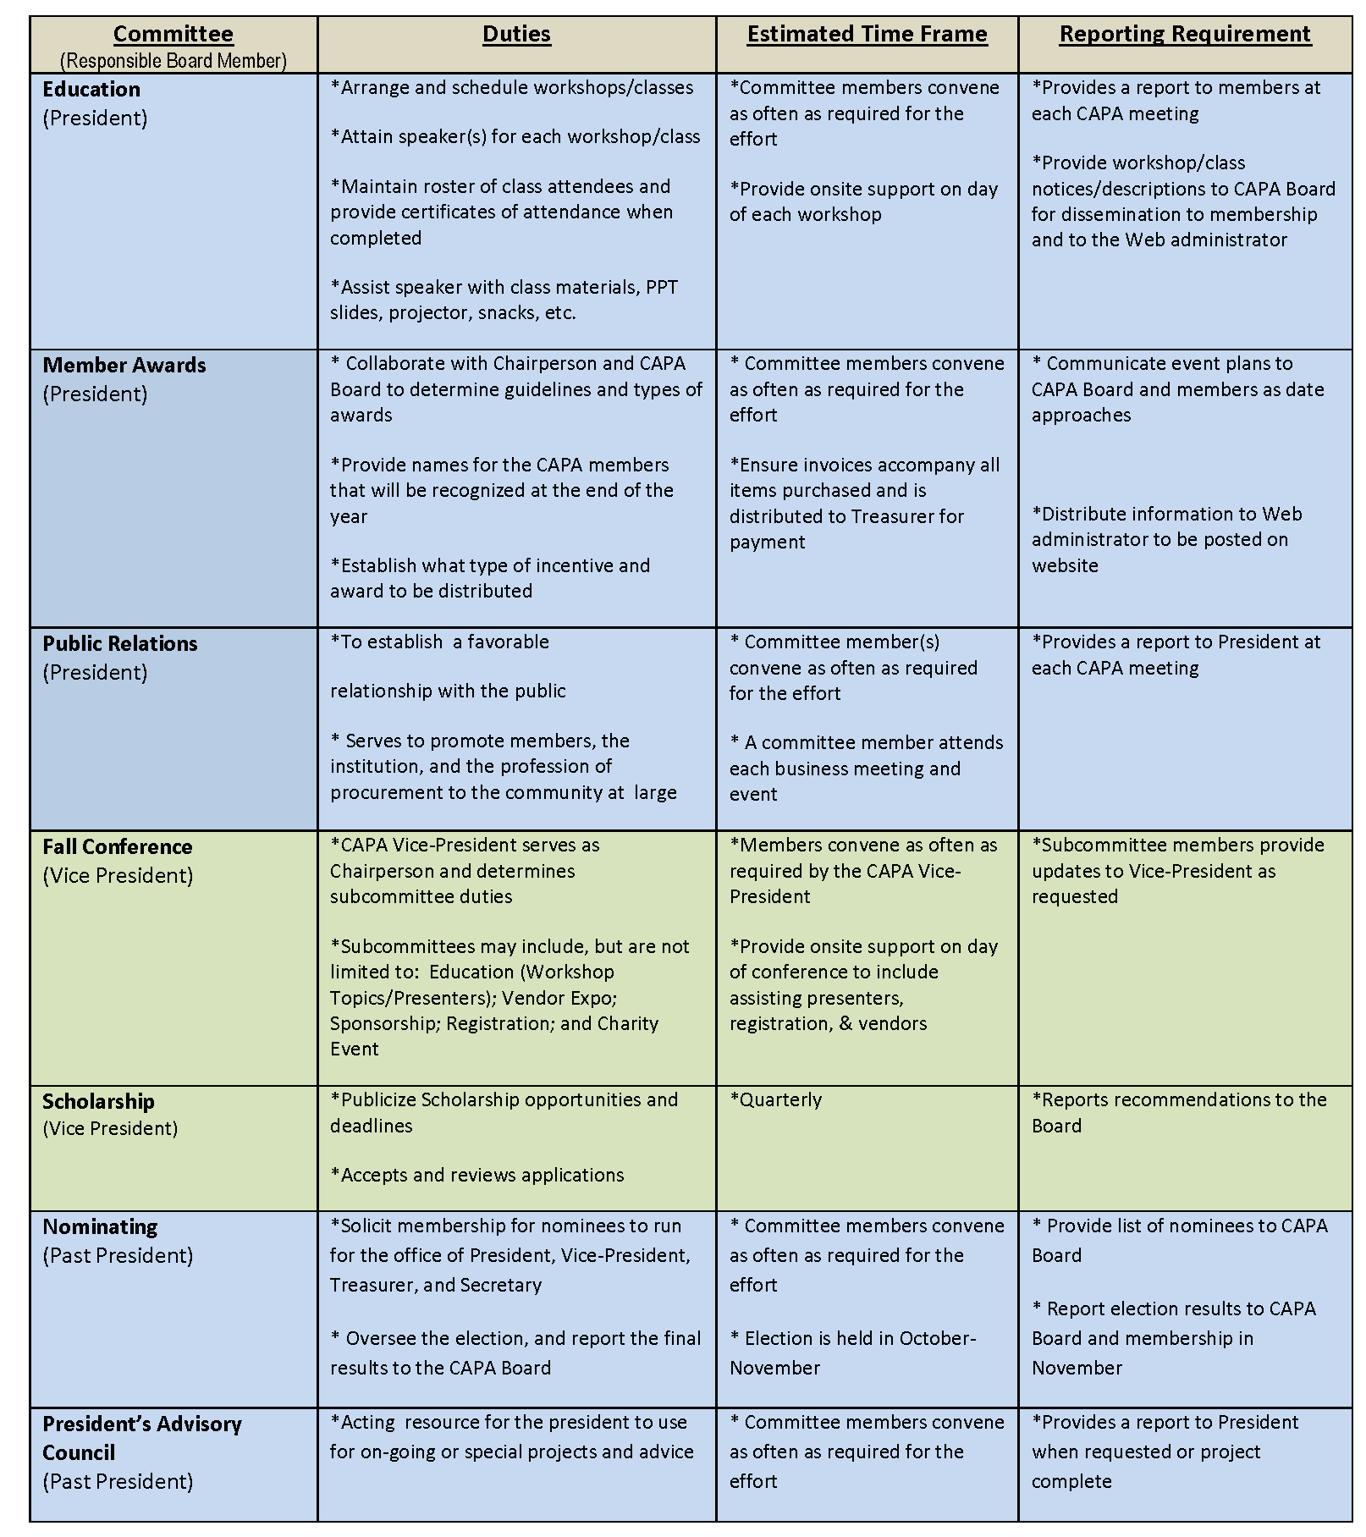


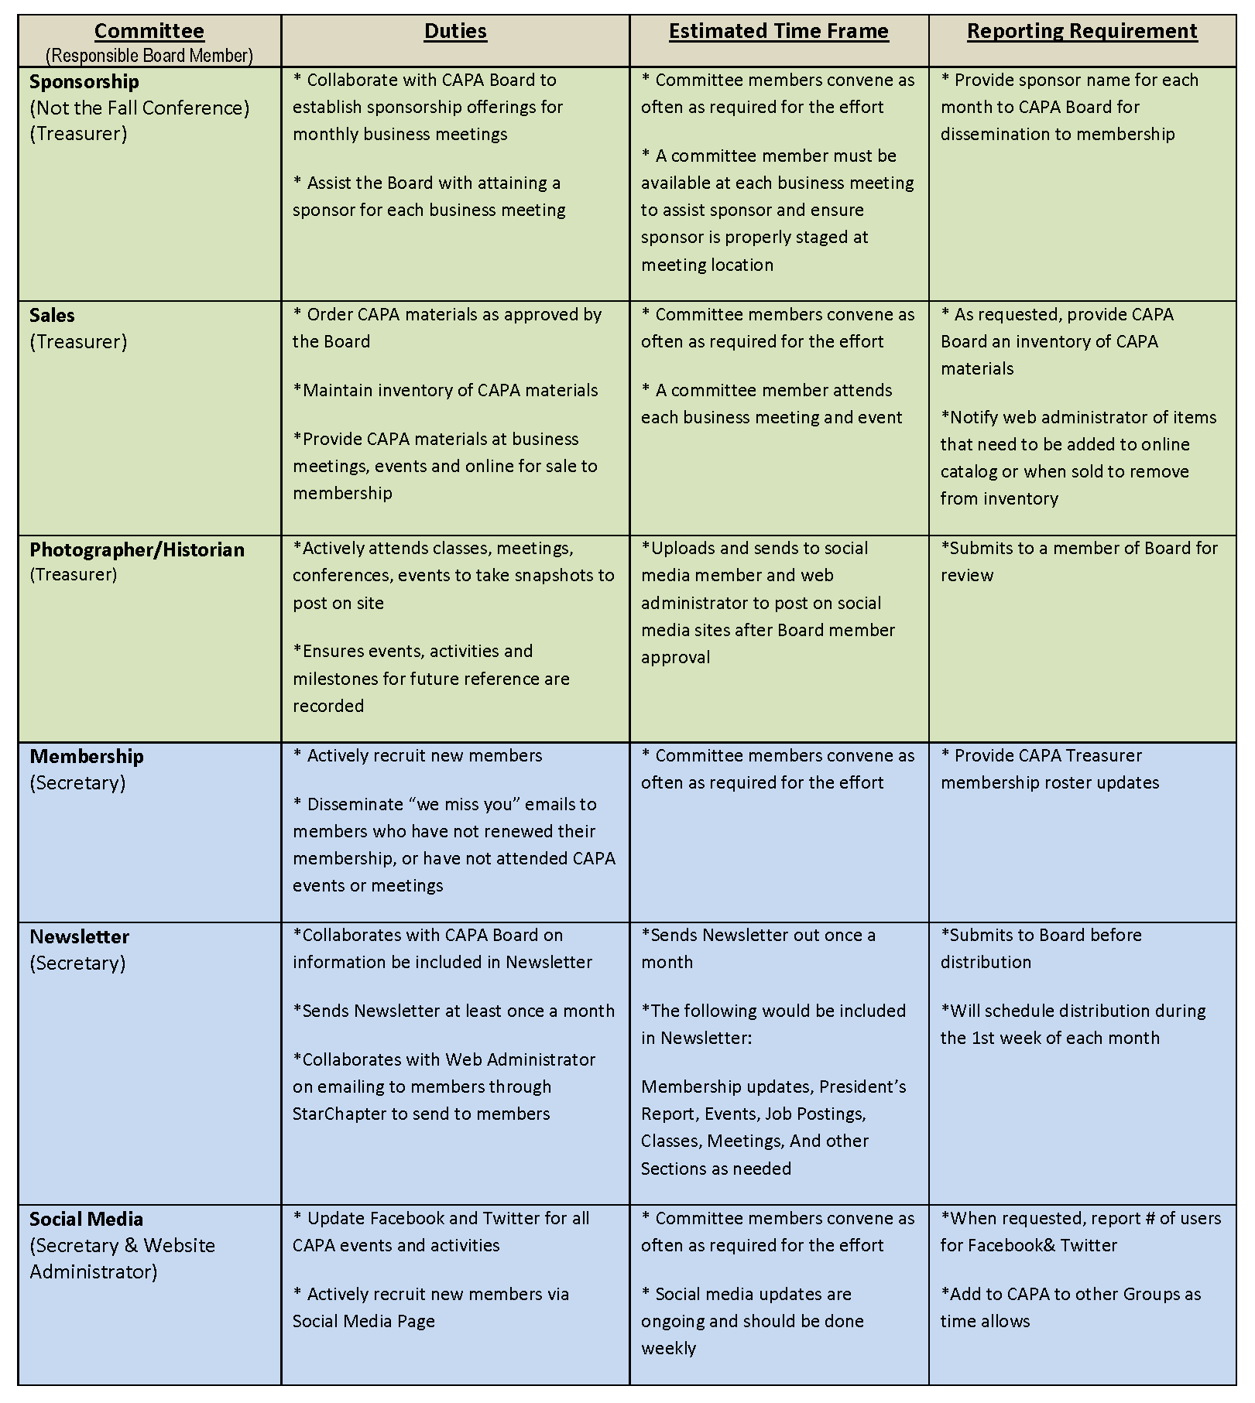
CHAPTER 9 – CAPA BUSINESS MEETINGS

CAPA Business meetings offer members a convenient way to receive updates on CAPA activities; to network with peers; to learn new topics or advice; enjoy a good meal; and earn continuing education units and/or recertification points. Business meetings usually consist of a sit down atmosphere providing a lunch, CAPA membership and committee information and an educational speaker. Occasionally a vendor may sponsor a meeting. In this case, they are afforded the opportunity to speak about their product/services and provide literature or other materials to the members.

PURCHASING MONTH

Each year, CAPA collaborates with the Virginia Association of Governmental Purchasing (VAGP) and the Governor of Virginia to designate March as Purchasing Month in the Commonwealth of Virginia. VAGP takes the lead on arranging the designation by sending a proclamation request to the Governor in late January or early February. The official proclamation is signed by the Governor and includes a reference to CAPA and VAGP. A copy of the proclamation is then posted on the CAPA website, and members are encouraged to celebrate the month by hosting activities at their respective agencies or during the monthly CAPA meeting. The CAPA Board may also choose to hold special events such as online trivia and giveaways throughout the month.

This is a time CAPA members can reflect on new ideas or bringing a guest or new member to the business meeting. The underlying theme for all activities during Procurement Month is the promotion and recognition of the field of Public Procurement.

MEETING SCHEDULE

As stipulated in the CAPA bylaws, Business meetings are to be held at least four (4) times from January through December. January is proposed Budget month, March is recognized as Government Purchasing Month, May for Board and Committee volunteers, June is for Annual Picnic and February, April or July the Reverse Trade Show.

Special events may be adopted and presented in place of a regular monthly meeting. Members should be notified of changes. The Annual Fall Conference serves as the meeting for September. October is for the Nominees of the Board, in November new Board members are announced and in December a meeting is reserved for awards and installation of the new Board members.

Business Meetings are traditionally scheduled for the second or third Tuesday/Wednesday of the month, except when preceded by a Monday holiday. They shall be located in the Metro Richmond area and held between the hours of 11:30a.m. Until 2:00p.m. This should allow for a 1.5 credit hour for the attendees. The President communicates the meeting dates and times to the membership; preferably during the beginning of the year to the members or as soon as information is obtained. Members are encouraged to provide input regarding location, topics and speakers.

Below is a sample of the new schedule established beginning January 2019:

Month | Description | Credit HRS
January (2nd or 3rd week in month) | CAPA Business Meeting 11:45am to 1:45pm ET Present Proposed Budget and Establish yearly goals | 1.5
February* | No Meeting | 0
March (2nd or 3rd week in month) | CAPA Business Meeting 11:45am to 1:45pm ET Government Procurement Month | 1.5
April* (or February or July) | Reverse Trade Show(TBD) No Meeting | 0
May | CAPA Board/Committee/Volunteer Members Meeting | 1
June (2nd or 3rd week in month) | Picnic in the Park-Summer Meeting-Picnic | 1.5
July-August | No Meeting | 0
September (2nd or 3rd week in month) | CAPA Annual Fall Conference & Vendor Exposition (Can be between 6-8 Credit Hours) | 7
October* (Depending on DGS Forum Schedule-Either No Meeting in October or November). | CAPA Business Meeting 11:45am to 1:45pm ET Present Board Nominees for Voting IF No Meeting Nominations/Bios for Board will be sent via email. | (1.5)
November* (Depending on DGS Forum Schedule-Either No Meeting in October or November). | CAPA Business Meeting 11:45am to 1:45pm ET Voting results for Nominees Presented IF No Meeting-Results of Nominees will be sent via email. | (1.5)
December (2nd or 3rd week in month) | CAPA Business Meeting New Board Swearing In-Awards-End of Year Meeting | 2.5
Total Hours Available a Year |  | 16.5

MEETING VENUE

The President locates a meeting venue; the space should accommodate approximately as little as 25 and up to 70 members. Lunch shall be provided, and may be catered by the venue or a third party.

All venue and lunch contracts are reviewed by the CAPA President and Treasurer and signed by the President or other authorized Board member as appointed. Expenses are not allowed to exceed the approved budget unless authorized by the CAPA Board of Directors.

CANCELLATION POLICY
A registration is a commitment to attend the event. However, we understand unforeseen events may arise and registrants are unable to attend due to employee’s schedules, workload conflicts, family emergency, and so forth. If a person registers for an event and experiences one of these situations, registrants are encouraged to find a substitute to attend in their place or they can apply their registration to the next meeting except in the result of a class, conference or NIGP event. In the likelihood a substitute is not possible or the registrant cannot attend the next meeting, the following cancellation policy will prevail.
- Business CAPA Luncheons or CAPA Low Fee Classes: Notify within twenty-four (24) hours of the meeting, preferably in writing by email for documentation;

- CAPA Fall Conference or NIGP Event: Notify within seven (7) days in advance of event, in writing by email for documentation.
Other events or situations will be decided on a case by case basis and determined by the President or another CAPA Board member. Notify Treasurer or a Board Member Immediately within the time listed above before meeting date or time or of other situations. The meeting fee may be refunded if guidelines for canceling are followed.
Repeated occurrences may result in revocation of the member’s privileges.
If other special cancellation requirements exist (e.g. Inclement Weather); it will be provided in the event announcement page and information emailed to registrants.
PROFESSIONAL SPEAKERS

To allow for continuing education units and recertification points, each meeting includes a 45-60 minute training presentation by a knowledgeable speaker. The President is responsible for reserving the speaker and establishing a topic. All presentations should be relevant to the procurement profession, and beneficial to the professional development of CAPA members.

To curtail expenses, every effort should be made to attain speakers who are willing to offer their services on a complimentary basis. Speakers normally receive a free lunch, and the opportunity to market books or materials at the end of the event. A small gift is presented to the speaker in the form of CAPA products or a gift card.

MEETING SPONSORSHIP

The President, Sponsorship committee or event coordinator (e.g. Education committee) may seek corporate sponsorship for each meeting or event. The recommended fee for meeting sponsorship is determined by the Board yearly. Sponsorship information will be posted to the CAPA website.

Sponsorship largely includes the following:
- Up to a five (5) minute presentation to membership;
- Lunch and speaker presentation;
- Table for marketing/company material inside the meeting room;
- Company logo, business card and mission statement on CAPA website prior to and for the month of the meeting.

Members are expected to network with the vendor before and after the event.

ANNOUNCEMENTS AND REGISTRATION

The President announces monthly meetings to the membership by way of an email sent from the CAPA website by the Web Administrator.
The announcement provides:
(1) A theme;
(2) A description of the guest speaker and his/her topic;
(3) Registration deadline;
(3) Any information which the President desires to convey before the event.

All meeting and event registrations are processed online at www.capavirginia.org. Members may register to attend meetings online using the register link that is included with the announcement. Normally the maximum notifications for each event range from four (4) emails for business meetings to eight (8) emails for conference or special event as a reminder to members and non-members to booster event registrations. This is the only form of notification CAPA sends out to inform members and non-members of the information. When members and non-members unsubscribe from the announcements, they will not be informed of current or upcoming events.

All non-members, guests or sponsors may also go to the website to register for the event. Click on the Schedule of Events or the Calendar for the link. Click on Register Now to sign up for the event. You may be asked to set-up an account, unless dues are paid, they will not be able to access the Members area.

Members and Non-Members are encouraged to send the email announcement to other Procurement Professionals within their agency and their network to increase attendance for CAPA events and to become a member.

Credit card payments are preferred and accepted online at the time of registration, or members may choose to pay onsite by check or cash at the event. There is a bypass payment option online to pay in person. A member may also pay by credit card at the meeting. All credit card information is secured and is not kept on file.

MEETING ROSTER

The CAPA Treasurer is responsible for retrieving a Registration List from the administrative area of the CAPA website before the meeting. A roster is created to track amounts due, and attendance. The roster is signed or initialed by the attendees to certify proof of attendance at the event to be eligible for recertification points per NIGP requirements. The Treasurer maintains the signed/initialed roster list with the CAPA binder for that calendar year. A copy of the roster list is distributed to the Secretary to be used as an aid for meeting minutes and attendees names. (Ref. Annex I).

MEETING AGENDA
The meeting agenda is based upon a Parliamentary procedure that helps guide the meeting. It does not have to be followed completely by the book; it may be adjusted to fit your organization.

PARLIAMENTARY PROCEDURE

What Is Parliamentary Procedure? It is a set of rules for conduct at meetings that allows everyone to be heard and to make decisions without confusion.

Why Is Parliamentary Procedure Important? Because it's a time tested method of conducting business at meetings and public gatherings. It can be adapted to fit the needs of any organization. Today, Robert's Rules of Order newly revised is the basic handbook of operation for most clubs, organizations and other groups. So it's important that everyone know these basic rules.

Organizations using Parliamentary Procedure usually follow a fixed order of business.

Below is a typical example:

- Call to order.
- Roll call of members present.
- Reading of minutes of last meeting.
- Officer’s reports.
- Committee reports.
- Special orders - Important business previously designated for consideration at this meeting.
- Unfinished business.
- New business.
- Announcements.
- Adjournment.

The method used by members to express themselves is in the form of moving motions. A motion is a proposal that the entire membership take action or a stand on an issue. Individual members can:

- Call to order.
- Second motions.
- Debate motions.
- Vote on motions.

Robert’s Rules of Order Summary Version is a more complete understanding of the Parliamentary Procedure. You can view this information at http://www.robertsrules.org or search Roberts Rules.

STANDARD CAPA MEETING AGENDA
Listed below is the standard agenda used for the CAPA monthly meetings. The President may include other agenda items as desired or needed.
  - Call to Order
  - Welcome
  - Meeting Sponsor (5 minutes provided for Sponsor to address Members)
  - Recognition
- Acknowledge Visitors and Guests;
- Acknowledge Members (New Certifications, Recertification’s, New Positions or Professional Accomplishments).
  - Prior Month Meeting Minutes
“The minutes for the (previous meeting date) meeting are on your tables. Are there any corrections or additions?”
- If YES, corrections/additions are discussed and noted by the CAPA Secretary;
- If NO, “The minutes stand approved as written and will be posted to the CAPA website”.
- Motion to Approve, Second.
  - Treasurer Report
- “Copies of the (month of previous meeting) Treasurer Report is on your tables. Are there any questions? If not, the Treasurer report will be filed for audit.
  - Guest Speaker
- Introduction
- Presentation
  - Committee Reports by Board Representatives
  - Business Agenda
  - Announcements
  - Prize Drawing (typically a $5.00 coupon for future meetings)
  - Adjournment

MEETING MINUTES

The Secretary or designated person captures the minutes at each monthly meeting. Minutes can usually be two (2) or more pages depending on the feedback provided. Use past tense phrases as this is a record of the previous meeting. There is no limit on how much information is recorded, but all reports, old and new business, new guests, certifications and recertification’s, jobs, announcements, committee information, prize winners, speaker name and topic, any information that is imperative to CAPA’s order of business, adjournment time and name of the person recording the minutes.

Prior minutes are presented to the members for review and for voting at the during the next CAPA business meeting. All minutes will be filed with the records both electronically and on a printed document. The Secretary shall maintain this file with the meeting minutes to be filed at the end of their yearly term with the CAPA records.

The procedure for compiling the minutes is:

- Obtain an agenda from the President and print a roster or retrieve one from the Treasurer prior to the meeting, this will be an aid in recording the minutes and capturing members names;
- It is suggested to record the meeting on a cell phone or on the CAPA recorder for information that may not of been documented or to allow for the Secretary to go back at a later time to create the meeting minutes;
- Provide a draft copy to the President for approval prior to the meeting that the minutes will be distributed;
- After approval, print and place two (2) copies of the Minutes from the previous meeting on each table at the current meeting;
- Send a copy of the Approved Minutes to the CAPA Website Administrator to be posted to website.

In the event the Secretary is unable to attend a meeting, it is essential they find a replacement to capture the meeting minutes. If no person is found, the Board must be notified immediately in order for one of the attending Board members to fulfill this duty or ask a member to fill in. (Ref. Annex J).

SAMPLE OF MEETING MINUTES
Capital Area Purchasing Association

Meeting Minutes for Date
The scheduled business meeting of the Capital Area Purchasing Association was held at the Venue Name and Location.
President Name called the meeting to order at time.
Opening Remarks.
Guest(s) and Member Recognition: President Name asked if there were new members, new certifications, re-certifications or new jobs/positions.
- Guests:
- New Members:
- New Certification/Recertification:
- New Jobs/Positions:
Officer’s Reports:
Secretary’s Date Minutes: President Name indicated the Month’s business meeting minutes were on each table for review. She asked for revisions, corrections, and / or questions. Motion to Approve Name, Seconded by Name. The members Approved. President Name stated the minutes will be filed accordingly by Secretary Name.
Treasurer’s Report: President Name indicated the Month Treasurer’s report was on the table and available for review. The President asked for questions. The President indicated the report will be filed for audit.
Old Business: President Name mentioned old business that was pending.
New Business: President Name mentioned new business.
Committee Reports: Record any information provided by Committee Chairpersons.
- Educational Committee:
- Social Committee:
- Nominating Committee:
- Scholarship Committee:
- Membership Committee:
- Sponsorship Committee:
- Fall Conference:

Announcements:
The next meeting will be held Place-Date-Time.

Program/Speaker/Topic:

Drawings for Lunch Coupons:

President Name called for an adjournment of the meeting. President Name thanked everyone for attending.
The meeting was adjourned at time.
Respectfully submitted, Name, Year CAPA Secretary

FINANCIAL “TREASURERS” REPORT

At each monthly meeting, the Treasurer is responsible for providing CAPA members a current report of revenue and expenditures at each monthly meeting. The procedure for issuing the report is:

- Submit a draft to the President for review prior to the next meeting date;
- Print and place two (2) copies of the Report on each table at the event;
3. Send a copy of the approved Treasurer’s Report to the CAPA Website Administrator to be posted to website.
Below is a sample format (may not be actual reporting data) for the Treasurer’s report, which includes the minimum reporting requirements.

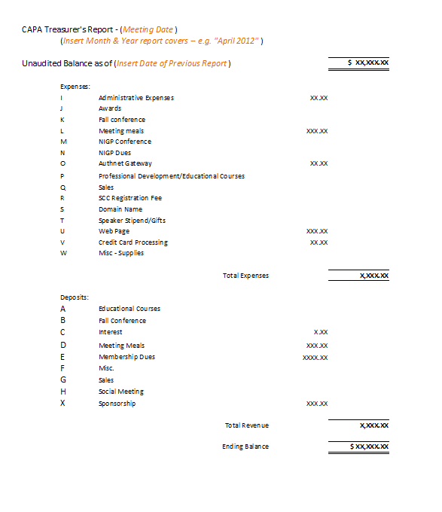

CHAPTER 10 – CAPA WEBSITE

The CAPA website www.capavirginia.org serves as the primary portal for online Chapter, NIGP and Regional chapter communication, registrations, payments, upcoming events, vendor information, educational classes, job listings, RSS procurement feeds, procurement resources, and other links and information.

STARCHAPTER FEES
The CAPA website is hosted by Star Chapter (www.starchapter.com). Subscription fees are $136 per month.
At the beginning of each year, Star Chapter records must be updated online in the administrative area of the CAPA website at www.capavirginia.org/admin. The update ensures that the CAPA Board of Directors receives notice of new advancements and features. As appropriate, the President and Web Administrator share administrative login credentials with Board members.
DOMAIN FEES
The Capital Area Purchasing Association CAPA domain name www.capavirginia.org is registered with Domain Monger at https://www.domainmonger.com.
As of 2012, CAPA purchased the exclusive rights to use www.capavirginia.org for 9 years. The usage rights are due to expire in 2021.

WEBSITE UPDATES
The Website Administrator has the duty of updating the CAPA website. At a minimum, standard updates should be performed on a weekly basis such as Job Postings, Educational Classes. Information that is outdated should be removed immediately. More urgent updates should be completed as they are received. The Website Administrator should be the sole content provider and will coordinate with the President prior to uploading information other than the standard updates or usual requirements.
CAPA ELECTRONIC NEWSLETTER
The Newsletter Editor shall distribute monthly a newsletter to the members electronically to keep them updated on job postings, classes, conferences, upcoming events, changes and other information that is pertinent to CAPA. The newsletter should also include a message from the President and any information that the other Board members want to relay to the members. Members are encouraged to submit articles or other information that may be of interest to the membership.
ANNOUCEMENT AND MEETING EMAILS
The Website administrator shall communicate to members via an email sent to selected groups such as Members, Non Members, Vendors, etc. from CAPA. All CAPA meetings and events will be posted to the meeting calendar through Star Chapter and displayed on the Calendar or through the Scheduled Events tab.
CAPA may post information on their website for other entities, this information would be provided by the Board members or from other Chapters or by member requests. Persons who have an account with CAPA will automatically be subscribed to notifications when account is created. If unsubscribed from the mailings, emails will not be delivered to the recipient and can only be restored per request.
NOTE: Email notifications are the main source of Communication to the Members and Guests of the Chapter.

JOB POSTINGS

Job postings can be requested by submitting the online form under the Job Postings tab on the CAPA website. Upload job postings directly to the CAPA website to include all job related information or by contacting the CAPA Website Administrator. The CAPA website will automatically email a notice to the requestor when the posting is complete or denied.

Job postings will be updated at least once weekly referencing the Virginia Jobs website for Procurement or related positions that are available. Special Job postings or postings from outside entities may be posted at the discretion of the President.

EDUCATION
Educational classes and courses will be posted for CAPA, NIGP, VAGP, VIP (Virginia Institute of Procurement), and VITA. If classes from other Chapters and Agencies are made available, these will all be posted to the site. The Education tab shall include if applicable the name of the class, the instructor, location, dates, objectives, costs, and a link to register.
RESOURCE LINKS
The Resource Link offers members a link to many agencies, colleges, localities and sites that aid in the procurement process. Other sites may be added or deleted as requested or as needed.
CATALOG
The Catalog (CAPA Sales) contains items that are available for sale to the public. The sale of these items helps support the CAPA Education Fund for Scholarships. Items may be added to or deleted to the site as they become available or unavailable. Fundraising information may be posted here as well.

SCHEDULED EVENTS

The Scheduled Events tab lists upcoming meetings, conferences or classes with a link for more information and to register. This coincides with the calendar on the home page.

BECOME A SPONSOR

The Become a Sponsor page spotlights the vendors that have sponsored events for CAPA. The page lists the Company Logo & Name, A Picture of the Business Representative, The Company’s Mission Statement, The Contact Information and a Link to the Company’s Website. There is information posted on sponsorship opportunities available.

MEMBER AND NON-MEMBER PAGE

These pages are accessible to the type of registration a person has with CAPA. Member pages have links to other information only accessible to paid or approved members.

LOGO

The CAPA logo may change over time as the Chapter evolves. Make sure to use the current logo on all documentation or correspondence as the log is registered with the NIGP. If the logo, SOP or Bylaws are changed or updated, send updated materials to NIGP as well for their records.
CHAPTER 11: SOCIAL MEDIA AND CAPA FEEDS
Social Media is a way to keep members updated on information and events. As technology is a major part of our lives, people are connected to these sites for real time updates via Facebook, Twitter and other Social Media sites. CAPA Feeds also aids in up to the minute information by providing a link to events and procurement issues that are in the news in real time now from around to the world to here.
SOCIAL MEDIA SITES
CAPA maintains an account with the following social media outlets to encourage dialogue among members and to provide timely information about chapter activities:
Facebook
Twitter
Instagram
The Social Media Chairperson and Committee (if applicable) is responsible for posting all updates, which may include event announcements, encouraging event participation, information about member achievements, photos, soliciting new members, tips and new trends in procurement. Login information is reserved for committee and CAPA Board members. Members may join the site per request. Other sites may be added or deleted at the discretion of the Board and the Social Media Committee.
CAPA FEEDS
CAPA feeds are an online environment for CAPA members to read blogs from Procurement and State Government resource sites on topics and information trending on a daily basis. Sites may be added or deleted to the CAPA FEEDS website page.
The sites may include the following:
- Virginia News
- GovDeal Auctions
- American City & County
- Procurement & Operations CED Blogs
- Chief Procurement Officer
- The Coalition for Government Procurement
- Sheppard Mullin-Gov Con-Government Contract Law
- Procurement Insights
- Purchasing Insight Coffee Break Podcast

These sites are Procurement or Government related links. CAPA does not support or condone any information that distresses its members. CAPA cannot monitor these sites 24 hours daily; members should report any instances where that they find derogatory or offensive material to the Board in order for them to determine if a site should be removed from the feeds.

CHAPTER 12 – SCHOLARSHIP PROGRAM

CAPA EDUCATION SCHOLARSHIP

In an effort to help promote the principles of CAPA, on April 1st, 2016, CAPA begun accepting applications for reimbursements or funding for Public Procurement or Supply Management related Educational workshops, classes, seminars, courses, conferences or forums locally or within the United States for current active CAPA members in good standing whom are interested in furthering the development of their procurement skills and professionalism. It applies to all areas of procurement enrichment and supply management opportunities.

The CAPA Education Scholarship provides financial reimbursement or funding to members seeking further Educational skills and knowledge relating to Procurement and Supply Management. The Scholarship Committee, along with guidance from the Board members, manages the Scholarship Program.

REIMBURSEMENT: EVENTS THAT APPLICANT HAS ATTENDED WITHIN THE TIME PERIOD LISTED.
Applicants must submit all supporting documentation for reimbursement to the CAPA Scholarship Committee for the specified session(s) or event:
- Scheduled between January 1st and June 30th turn paperwork in by September 30th;
- Scheduled between July 1st and December 31st turn paperwork in by March 31st ^{of} following year.

FUNDING: FOR FUTURE EVENTS THAT APPLICANT HAS NOT YET ATTENDED BUT WILL IN THE TIME FRAME LISTED.
Applicants must submit all supporting documentation for funding to the CAPA Scholarship Committee for the specified session(s) or event:
- Scheduled between January 1st and June 30th turn paperwork in between December 1st and May 31st.
- Scheduled between July 1st and December 31st turn paperwork in between June 1st and January 31st.

NOTE: If an event needs to be paid more than one month in advance, paperwork can be turned in earlier.

The Committee reviews all completed applications and makes a determination regarding who will receive an award and how much the reimbursement or funding will be provided. The Committee then presents its recommendation(s) to the Board for review and approval. The number and amount of reimbursements may be limited based upon the amount of scholarship funds available at the time of submission(s) and shall be limited to one (1) applicant package and one (1) scholarship request per member, per year. Awards, if any, will be announced at the next monthly meeting and posted on the CAPA website. The CAPA Treasurer issues the approved scholarship award in the form of a check within fifteen (15) days after the approval to the person listed on the application. (Ref. Annex L).
The Scholarship Committee along with the Board will make a decision based on the following criteria:
- Applicant’s demonstrated commitment to the field of procurement or related industry as demonstrated through service to CAPA, NIGP or other procurement sponsored organizations;
- Compatibility of the session to Public Procurement, Supply Management or other related field;
- Applicant’s responses to required information and written content on the Essay Questions;
- Completeness and content of the application form and package including all receipts and other documentation as stated.

DENIAL: An applicant not receiving an award shall be notified in writing stating as to the reason(s) of the applicant was unsuccessful. Please allow 4-6 weeks after submittal of application and documentation for review, evaluation, selection and notification.
The CAPA Board will maintain a record of all member reimbursement requests scholarship applications received. The Scholarship committee will provide a quarterly report on all scholarship activity during that period to the membership.
WHAT DOES IT COVER?

- VAGP, NIGP, CAPA sponsored Seminars, Classes or other educational functions.
- Public Procurement Forums or other Conferences that count towards educational points for Certification or Recertification.
- Professional Procurement Certification or Recertification Fees.
- Tuition for an accredited college or university course in which the course major subject content is centered on procurement, or materials and supply management.
- Training materials or books specifically related to an accredited college, university, UPPCC, CAPA, NIGP, VAGP or other procurement session, that are not included in the price of the session.
- Other public procurement session(s) not listed above may be considered. The CAPA Board will determine if it is applicable.
WHAT DOCUMENTS ARE NEEDED?
A complete scholarship application consists of the following items;
- A completed and signed CAPA Education Scholarship Application Form by the applicant;

- Essay Questions answered completely. The questions are for both Funding and Reimbursements. Be specific and provide details. (This will be counted as a determining factor for approval);

- A copy or print out of an email, brochure, flyer, webpage, syllabus, statement or other documentation describing the session, course, or objectives;

- Receipt(s), Quote or Documentation showing price of the procurement session and material information;
Optional:
- Additional documents may be submitted for evaluation purposes such as a letter of recommendation or a nomination memo or letter from a supervisor, colleague or teacher.
ESSAY QUESTION REQUIREMENTS

The required Essay Questions are to accompany the application form. Ensure that the Essay Questions are answered thoroughly with pertinent information. This will be part of the evaluation process of the Board. Use additional paper to answer the questions if needed; please keep additional pages to three (3) pages maximum. (Ref. Annex M).
Make sure the document is typed, printed or written legibly. Board is not responsible for not being to read illegible printing or writing. Illegible documents may receive lower review and grammar and spelling will be considered, but will not be a disqualifying factor.

The completed application package should be fastened if submitted manually, (unless faxed), or submitted in one (1) executable file electronically, and submitted to the Scholarship committee as instructed on the application. Applicant may bind the Essay or insert into folder for presentation quality. Include the Essay Questions with the application and other documents when submitting to CAPA.

SCHOLARSHIP EVALUATION SELECTION PROCESS

Upon receipt of the Procurement Education Scholarship application package, the CAPA Scholarship Committee shall review the package for criteria described below. All applications that are received will be reviewed and either approved or denied. Please note, all Scholarship application packages submitted will not guarantee a reimbursement.
The Scholarship Committee along with the Board will make a decision based on the following criteria:
- Applicant’s demonstrated commitment to the field of procurement or related field;
- Compatibility of the session to Public Procurement, Supply Management or other related field;
- Applicant’s responses to required information and written content to the Essay Questions;
- Completeness of the application form and package including all receipts and other documentation as stated.

An example of the application form to be completed along with the other requirements full details can be found on the CAPA website. (Application is posted on CAPA website).

CHAPTER 13: RECORDS MANAGEMENT
Records Management is the professional practice of managing the records of an organization throughout its Life Cycle (creation, modification, movement, and destruction of records); from the time they are created to their eventual disposal. This includes categorizing, labeling, storing, securing, retrieving, tracking and destroying or permanently preserving records. Not all documents or electronic data are considered records. A record is a document or data knowingly retained as evidence of an action of conducting business and is something that represents proof of existence.
The increased importance of transparency and accountability in public administration, marked by the widespread adoption of Freedom of Information laws, has led to a focus on the need to manage records so that they can be easily accessed by the public.
The practice of records management may involve:
- Planning the information needs of an organization;
- Identifying information that requires capturing;
- Creating, approving, and enforcing policies and practices regarding records, including their organization and disposal;
- Developing a records storage plan, which includes the short term housing of physical records and long-term retention of digital information;
- Identifying, classifying, and storing records;
- Records must be stored in such a way that they are accessible and safeguarded against environmental damage. A typical paper document may be stored in a filing cabinet in an office;
- Coordinating access to records internally and outside of the organization, balancing the requirements of business confidentiality, data privacy, and public access;
- Identification and maintenance of records per a specified retention period;
- Executing a retention policy on the disposal of records which are no longer required for operational reasons; according to organizational policies, statutory requirements, and other regulations, this may involve their destruction. Disposal of records does not always mean destruction; it can also include transfer to a historical archive, or permanent preservation in an archive.
The level of data, electronic or material, shall not lessen the responsibility of the Chapter or its Officers, Chairs or its Committee members in safeguarding data that may be considered personally identifiable information. No credit card shall be kept on file and must be destroyed immediately after a payment is registered. If a document contains credit card information that needs to be kept on file, a redacted copy shall be created.
No social security numbers are required or requested by the CAPA organization.

Material documents that contain confidential information should be shredded, incinerated or pulped when no longer necessary or nearing the retention period. Electronic data should be expunged, cleared, completely deleted or erased.

LAPTOP SECURITY
The laptop shall be held in a secure location and only CAPA Board or designated members will be allowed to access the data. When the laptop is used for presentations, the laptop shall not be left unattended by a Board member or designated person. The pass code should only be shared between the Board or designated members.
No personal membership information such as credit card information, social security numbers or other confidential information shall be kept on the laptop. The laptop is not for personal usage.
CONVERSION OF MATERIAL AND ELECTRONIC RECORDS
Within the organizations resources, the conversion of existing or incoming paper records shall be converted to electronic form. The conversions are with the intent of saving storage costs, storage space, and in hopes of reducing records retrieval time. Historical material records shall be copied onto a USB flash/jump drive or disc and maintained in one central location with the organization’s records. At least (3) copies should be kept on file with the records.

Each year, the Board of Directors shall be issued a flash/jump drive/disc to retain their information throughout the year. All Documents should be scanned and recorded. Electronic data shall also be recorded. At the end of their term, the flash/jump drive/disc shall be placed into the files for records retention.
RECORDS RETENTION
Just as the records of the organization come in a variety of formats, the storage of records can vary throughout the organization. File maintenance may be carried out by the Board or by suggestion of the records custodian. Records shall be managed in a centralized location.
Records may be formally and discretely identified by indexing and housed in folders designed for protection and storage capacity, or they may be casually identified. Filing maintenance and storage systems in various locations can prove to be costly in terms of wasted space and resources expended searching for records.
A designated member shall be the custodian of the records. The records should be kept at one location and recommendations for additions or deletions should be submitted to the Board.
The following is a suggested records retention schedule from NIGP.

Record Retention Schedule
(As suggested by NIGP)

Banking Information

Accounts Payable Ledger/History Files |  |  |  |  |  | Permanent
Accounts Receivable Ledger |  |  |  |  |  | Six Years
Bank Deposits/Receipts |  |  |  |  |  | Seven Years
Bank Statements/Reconciliations |  |  |  |  |  | Seven Years
Billings |  |  |  |  |  | Three Years
Bills/invoices from consultants, vendors |  |  |  |  |  | Six Years
Budget Projections/Files |  |  |  |  |  | Two Years
Cash Receipts |  |  |  |  |  | Seven Years
Checks Paid/Cancelled |  |  |  |  |  | Seven Years
Donations |  |  |  |  |  | Six Years
Financial Statements – Audited |  |  |  |  |  | Permanent
General Ledger Detail – Year End Closing |  |  |  |  |  | Seven Years
Revenue Posting |  |  |  |  |  | Two Years
Statement of Miscellaneous Income (Form 1099) |  |  |  |  |  | Eight Years
Tax Returns / IRS  Correspondence |  |  |  |  |  | Permanent
Accounting |  |  |  |  |  | Five Years
Credit and Collection |  |  |  |  |  | Seven Years
Tax |  |  |  |  |  | Permanent
Dues Records |  |  |  |  |  | Three Years
Meeting Minutes  Miscellaneous |  |  |  |  |  | Permanent
Capital Assets |  |  |  |  |  | Three Years
Contracts - Vendors |  |  |  |  |  | Permanent
Bylaws |  |  |  |  |  | Permanent
Operations Manuals |  |  |  |  |  | Permanent
Registration with state as nonprofit organization |  |  |  |  |  | Permanent
Tax Exemption |  |  |  |  |  | Permanent

CHAPTER 14– FALL CONFERENCE AND VENDOR EXPOSITION

CAPA’s Annual Fall Conference and Vendor Exposition is an opportunity for the CAPA members and guests to interact with their peers to learn new techniques meet with vendors to earn recertification points and network for a day. The Vice-President serves as the committee chairperson and is responsible for all aspects of the planning and execution. The Vice President has express authority to enter agreements as if necessary to ensure continuity, but must have the President’s approval. The Fall Conference is generally held during the 2nd or 3rd week of September but can change depending on venue availability or other potential schedule conflicts. The one-day event provides a full day of workshops, keynote speakers, as well as a vendor exposition. All Board members must participate in this event. There is no charge to the Board members to attend.

FC VENUE CONTRACT

The Vice President is responsible for locating a venue for the event and obtaining a contract immediately following the current year’s conference. The venue deposit should be included with the prior year’s budget (e.g. 2017 deposit for 2018 Fall Conference). The conference committee (if formed) and/or Board shall provide input to the venue selection and vote established (majority rules) before finalized.

The venue should offer at a minimum:

- Adequate training space for a minimum of 100 conference attendees;
- Food and beverage for breakfast, lunch and breaks;
- Convenient location with on-site parking and preferably located within a 25-mile radius of center Richmond center;
- Easily accessible for all attendees or accommodations provided by venue;
- Include exhibit space for a vendor exposition, with a minimum of 20 booths;
- Acceptance of NIGP insurance coverage (see NIGP Website www.nigp.org ).

FC COMMITTEE

The Vice-President solicits CAPA members to volunteer for the Fall Conference Committee. The committee is chaired by the Vice-President, and generally includes a set of sub-committees to address specific duties leading up to and on the day of the event. Sub-committees may include:

- Marketing
- Develop marketing scheme to alert members and public
- e.g., brochures, posters, website posts, emails
- Inform members of upcoming events, members news or other useful info
- Registration
    - Creates and disseminates registration materials
    - Oversees registration before and during the event
    - Compiles conference packets and materials
    - Creates Nametags for attendees
- Education
    - Surveys membership for workshop topics (this is usually done the prior year)
    - Locates Speakers for desired workshops
    - Creates recertification form for attendees
    - Gets recertification form approved by VIP
    - Creates roster sheets for classes and solicits persons to proctor classes
- Catering
    - Locates caterer for event (only if venue does not provide caterer)
    - Selects food for breakfast, lunch, and breaks
    - Make sure schedule is correct before day of event
- Charity Event (50/50 or Extra Ticketed Event)
    - Determines charity organization for event
    - Promote and disseminate information to membership
    - Establish flyers or poster
- Vendor Exposition
- Solicits vendors to sponsor the Fall Conference Exposition
- Solicits vendors for to sponsor a booth
- Provide a class for vendors
- Asks vendors for donations
- Scholarship
- Arranges for fund raising events to fund scholarship account
- Sales
- Provides items for purchase during the event

If needed to manage the activity of the sub-committee and approved by the President, sub-committee chairpersons and those assisting in areas of the conference during that day, may be granted access to the conference at no charge. If committee member is not and has not been an active participant, they shall not be permitted free of charge to event.

FC THEME

Besides securing a venue, a theme for your event is another task that needs to be completed immediately. At this time, the Committee or you create a logo to along with your theme. This will be posted on registration forms, flyers, brochures, bags and be the draw for your event.

When creating a logo, limit the size and colors and this will be used on printed materials. Once the theme and venue are established, you may post the information on the website and solicit vendors and attendees.

FC PRICING

The pricing for the Fall Conference can vary from year to year. You may keep the same pricing as the year before or raise the pricing. (Try to keep price competitive with other Chapter’s equivalent events). Try not to go down in price and this may cause future events to follow suite. This also is the same for sponsorship opportunities which will be explained in more detail under Sponsorship.

FC SCHEDULE

Immediately begin working on a Schedule of Events when you know the date the conference will take place. A schedule will facilitate the event keep the day running smoothly. Reach out to your keynote and classroom speakers to reserve their time. As an event gets closer, it becomes difficult to obtain person(s) to host at the conference. There may be some costs involved in obtaining a speaker, DO NOT GO over your allocated Budget. Any costs over $3,000 needs to be discussed with the Board. (Ref. Annex N).

Make sure to schedule the following at a minimum.
- Registration
- Breakfast
- Morning Keynote Speaker (can be (2) sessions back to back)
- Two Morning Breakout Sessions
- Lunch
- Vendor Exposition
- Two Afternoon Breakout Sessions
- Closing Keynote Speaker

During closing, thank your speakers, sponsors, guests and Committee members.

RECERTIFICATION FORMS

Let attendees know that the Recertification Forms will be emailed to them and they will have to sign and return to you. You will then send a list of names along with the forms to VIP (Virginia Institute of Procurement) for them to record the information under the attendees account. The forms need to be compared to the rosters from the FC Event to verify class attendance.

Have a list of names comprised from registration to mark through when an attendee returns their form. Reach out to those who have not turned in the paperwork. If you have an electronic file of forms returned, you may destroy the paper versions (if applicable).

SPONSORSHIP-DONATION PAPERWORK

When soliciting for sponsors or vendors for donations, ensure that paperwork is completed to retain on file for audit purposes. Companies will report this on their taxes as a business or charity expense. Paperwork should be kept with official conference file and with the records custodian. The record should contain the dollar or in-kind amount of donation/sponsorship, date(s) of donation and event, company name and contact person and a description of what was offered in return of sponsorship. (E.g. lunch, booth/table, web posting, etc.). (Ref. Annex O).

VENDOR EXPOSITION

The Vendor Exposition offers CAPA members an opportunity to network with various suppliers and vendors and is an opportunity for CAPA Fall Conference attendees to meet new potential prospects who vie to do business within Virginia. This also aids in supplementing the costs of the conference through sponsorships and donations. Most vendors offer company material and speak with individuals on products or services they have to offer. Vendors may even offer items such as cups, pens, notepads or other small items as a token for conference attendees. CAPA expects the attendees to meet with the vendors to build a relationship and explore what they have to offer.

Vendors should be offered at the minimum for participation:

  - Signage on tables;
  - Draped or covered table, at least standard size, 6ft long x 2ft wide w/(2) chairs;
  - Company information posted on website, on flyers, and verbal recognition during conference;
  - Offer electricity and Wi-Fi if available;
  - Provide an opportunity for sponsor to participate in the lunch, breaks (breakfast if applicable) and classes.

FC SPONSORSHIP

Sponsorship plays an important part of the conference by supplementing costs. Prices and offerings are only examples, and may be adjusted higher or lower as the Vice-President and Conference Committee considers appropriate or depending on the Economy during the time of the show.

The example lists the sponsorship opportunities, which are generally made available to all vendors. In the example, vendors are allowed to purchase different sponsorship levels for participation during the conference with slightly different benefits. (Ref. Annex P).

During registration, there may be vendors who sign up to participate in the conference. Instead of having to do refunds or lose potential funding, offer the vendor a basic booth at the cost they paid to attend the conference. Also, donations made by a vendor can used in lieu of actual monies.

For e.g. a vendor donates 100 bags and the estimated cost would be $400, this can defray the cost of the sponsorship and provide you with bags for the conference.

We may be a non-profit organization, but we still need funding to exist. Donations are always a welcome Gift!

CHECKLIST FOR FALL CONFERENCE
MONTH | DESCRIPTION
September – January | Work On Venue, Theme, Logo And Registration Documents To Have Publicly Posted
January-May | Solicit Speakers For Event; Post Venue and Theme; Work On Sponsorship And Attendees and Door Prizes
January-May | Schedule Committee Meeting; Assign Roles
June-July | Obtain Topics And Biographies From Speakers; Continue Working On Sponsorship And Attendees and Door Prizes
August | Schedule Committee Meeting; Obtain Status of Duties
August | Finalize Menu And Schedule (along with approval from Committee and/or Board); Provide Map Of Venue And Directions; Continue Working On Sponsorship And Attendees and Door Prizes
September | Ensure Venue Has Updated Schedule, Reach Out To Speakers (2) Weeks Before Conference, Send Email To Registered Sponsors On What To Expect, Print All Materials, Have Centerpieces Ready, Decorations, Bags, Items To Go In Bags, Speaker Gifts/Thank You Note, Recertification Form ( To Be Emailed), Equipment And Table Cloths If Needed.  (Reach out to Board and/or Committee if Additional Help is Needed).
September | After Conference, Take A Break, You Deserve It!

CHAPTER 15 – REVERSE TRADE SHOW

CAPA may host a Reverse Trade Show (RTS) during the year. A Reverse Trade Show is similar to a vendor exposition; however, rather than having vendor exhibits, the participating agency maintains a booth while vendors visit for business opportunities. This event is normally held in the spring, but can be held anytime throughout the year. This is an opportunity for vendors to visit with agencies to find out their needs and to introduce themselves. Networking is highly encouraged.

The show should be at least a half-day event, four (4) hours minimum, to allow time for networking, set-up and to work with attendees schedules.

MEMBER SUPPORT

The President or Vice-President may work with an established committee or create a committee to assist with designating a venue, schedule, theme, catering and other areas as requested.

VENUE CONTRACT

The RTS, like the Fall Conference, should establish a contract with the venue to reserve the space and the date immediately in order to begin the planning process. The RTS should be held between April-June to allow time to prep and solicit sponsors, participants and attendees. The RTS can be held in place of the monthly business meeting. An educational class or keynote speaker can be provided as an extra incentive for participants.
- The venue must allow or cater food services for the attendees. Full day shows should include a breakfast option and lunch. A half-day show should include a break menu and may or may not include breakfast or lunch;
- Convenient location with on-site parking and preferably located within a 25-mile radius of center Richmond center (unless targeting a specific location) outside of Richmond;
- Easily accessible to all attendees;
- Include exhibit space for the participating agencies, with a minimum of 20 booths;
- Acceptance of NIGP insurance coverage (see NIGP Website www.nigp.org ).
The intent to host the event should be publicized at least three (3) months in advance. Agencies are solicited and encouraged to participate at least two (2) months in advance of the RTS show to ensure agency participation.

AGENCIES

The Reverse Trade Show consists of state, local, educational and other public body agencies throughout the Commonwealth of Virginia. Agencies do not have to pay to have a booth/table at the RTS. Normally, an agency sends two of their employees to meet and network with vendors. An agency may pay an additional fee for additional meals beyond the normal allowance of attendees. Each agency hosting a table should supply information on what types of commodities and services procured and the persons to contact. Items of nominal value may be distributed to the attendees.

RTS shows can be general or trade-specific. Each offers an occasion to expand networking opportunities.

The following are Key points to accentuate to agencies:

- It only Takes One Day of your agency’s time;
- Only One (1) Agency Representative Is Required to host a booth throughout the day, however, two (2) agency representatives are recommended;
- Provide Information about conducting business with your agency, procurement opportunities, business cards, outreach events, etc.;
- By participating in the trade show Makes Valuable New Business Contacts;
- It is an Excellent Outreach opportunity.
VENDORS
The Reverse Trade Show focuses around the vendor. The vendors are the persons who pay a registration fee to attend the RTS or they may sponsor this event. This is the vendor’s opportunity to meet with the agency procurement professionals and/or staff to discover what products or services are being utilized within that agency. Vendors have an opportunity to get first-hand information on how to “do business” with a variety of organizations.
Here are some key points to accentuate to the vendors:
- Meet face to face with various government purchasing professionals , no cold calls, no hang ups, no voicemails, no internet surfing or appointments, all under one roof in one day;
- Networking Sessions ensures Vendor-Agency Time, schedule throughout event;
- Gather each agency’s business information, current bid/contract solicitations, contact information, etc.;
- Learn each agency’s procurement regulations and procedures;
- Network with government procurement professionals and other potential business partners.
SAMPLE SCHEDULE
Below is a sample schedule of a Reverse Trade Show. This can be adjusted to fit your theme, meeting time, and available dates. More samples of Reverse Trade Shows can be found at the NIGP website. http://www.nigp.org/home/membership/chapters/resources/reverse-trade-shows .
The Reverse Trade Show / Half-Day Event
8:30am-12pm Schedule (Sample)
8:00am – 12:00pm Vendor Registration/Sign-In
8:00am – 11:00am Continental or Full Breakfast & Beverage
8:30am Opening Remarks by President/Committee Chairperson
(Great photo or speaking opportunity for the title sponsor)

8:30am –12:00pm Reverse Trade Show Exhibit Floor Open
9:00am – 11:00am Concurrent Educational Workshops & Networking Opportunities
(Current and Relevant Topics, Avoid Politics; Time Networking Sessions, Keep them Moving)

11:45am Closing Ceremony Statements and Acknowledgements

12:00pm End Show

CHAPTER 16 – CAPA SALES AND FUNDRAISING

CAPA product sales are essential in bringing in funds to the organization throughout the year for Education, Scholarship and other uses within the membership. These items are available for purchase during special events and through the online catalog at all times.

A Sales Committee handles the products to be sold and it is their responsibility to:
- Promote sales,
- Maintain inventory,
- Track sales information,
- Order new products,
- Handle customer issues/concerns,
- Deliver or ship items to the customer.

INVENTORY STORAGE
The inventory items are to be kept in the storage unit that is currently being located at Mini Storage 318 Cowardin Ave, Richmond, VA 23224 is accessible to the Board members. The Sales person can notify the Board when these Items sell and they must be readily available when requested or when sold.

PRICING
The Board along with the Sales Committee will decide the pricing of the items. Prices may be adjusted according to sales.
RESTOCK PRODUCTS
The Board along with the Sales Committee may decide on what items are to be purchased to sell or from requests from board members, or from the results of a survey.
ONLINE CATALOG
An online catalog displays the items that are for sale, the price and can be purchased through the website. It is the Sales Committee responsibility to let the person updating the website a picture of the item, the amount in stock and the price of the item.
INVENTORY REPORT
A quarterly inventory report should be completed every four (4) months listing the items in stock, quantity of items, sales information and money collected. This report shall be submitted to the Treasurer and President. Any discrepancies, damages or missing items shall be reported to the President immediately.
CUSTOMER SATISFACTION
In some cases, inventory may be damaged, not what the customer expected, wrong size or other reasons. We want to make sure people who purchase our CAPA items are satisfied with their purchase. CAPA does consider the money collected from the sale as a donation and it is used towards the Education Funds.
However, for purchases within the first thirty (30) days, every effort will be made to satisfy the customer by either replacing the item with the same or an equivalent item. Size issues will be exchanged for the correct size if available. Refunds would have to be decided by the Board of Directors and the Sales Committee Chairperson based upon the reason of return on a case by case basis.

FUNDRAISING
Outside fundraising can be a way to bring funds into CAPA without having to utilize an extensive amount of funds to purchase items that may not sell or take long periods of time. This option can provide members or non-members the opportunity to purchase items they can use immediately or may be of better interest to the purchaser. Local groups provide fundraising materials at a small cost to non-profit organizations to help organizations bring funds into their Chapters.
FUNDRAISING IDEAS
There are many ways to sell fundraising products or host a fundraising event; below are a few ideas. The membership can utilize one of these ideas or create their own.

Sell items such as:
- Doughnuts,
- Popcorn,
- Cookies,
- Candles,
- Entertainment Books,
- Peanut Sales,
- Other Products.

Host events to bring in funds such as:
- Chili Cook Off,
- Silent Auction,
- Bake Off,
- Walk-A-Thons,
- Golf Tournament,
- Partner With A Restaurant,
- Flower Sales,
- Craft Sales
- And Other Events That Can Bring In Funds.

CHAPTER 17 – STORAGE UNIT: EQUIPMENT AND SUPPLIES

As we progress into the future, it becomes necessary for CAPA to invest in supplies and equipment. A one-time expenditure ensures appropriate use of resources for this purchase. Currently CAPA has the following equipment listed below. The equipment is generally stored in the storage unit located at Mini Storage 318 Cowardin Ave, Richmond, VA 23224. However, Board members and committee chairs may maintain and store the equipment if used frequently with approval from the President. Equipment must be available upon request for CAPA meetings or events. CAPA equipment may not be used for personal reasons.

At the end of the calendar year, inventory will be conducted on the items in storage. The Board members will be responsible for any items missing or damaged and not reported to all the Board members at the time observed; Board will determine if replacement is necessary. For e.g. A glass jar breaks during the May meeting, report this to the Board immediately to be documented.

The President shall be notified of items being loaned to Members or other persons.

PROJECTION SCREEN
Epson Accolade Duet Ultra-Portable Projection Screen. Item # 508635.
- Design allows flexible setup. Screen can be propped atop a floor stand or mounted on a wall using a bracket (stand and bracket both included).
- Supports both standard and widescreen formats. Choose either standard 4:3 format (65" diagonal) or widescreen 16:9 format (80" diagonal).
- Closes up for easy carrying. Carrying case is included.

PROJECTOR
Epson VS230 LCD Projector 2800 Lumens, Video Input Video Interfaces: VGA, HDMI, composite video, S-Video. Includes Remote Control and HDMI Cable, Power Cord. Item# V11H55220.

Soft carrying case. Item# V12H001K67.

PRESENTER

Wireless Presenter, Doosl Rechargeable Wireless Presenter, 2.4GHz PowerPoint Presentation Remote Control with LCD Display.

LASER POINTER
Compact 5mW 532nm Mid-open Green Laser Light Pointer, Black. Item# 88006856. Points about 100 meters.
PRINTER
Canon PIXMA MG3520 Wireless Photo All-in-One Inkjet Printer, White.

ADAPTORS
(3) HDMI to DVI 1M Adaptor Cable, 3 Feet. Flexible cable adapts a DVI output to an HDMI input.
(2) Gold Plated Display Port to DVI Cable (adapter). Able to DVI monitor to a Display Port equipped computer or Laptop.
CAPA SIGN
48-inch Economy Retractor Kit - Black Hardware.
LAPTOP
HP Pavilion T5 15” Notebook PC 4GB, 64 Bit, Full Windows Touch Support, Windows 8.1
(THIS IS ONLY USED BY THE CAPA BOARD OF DIRECTORS AND IS NOT AVAILABLE TO CAPA MEMBERS.)

RECORDER
ZOOM H2 Handy Recorder, 1GB SD Memory Card, Stereo Recording. A86416534, 413534.

EASELS
Eight (8) Portable Easels in Carry Bags. Assembled Measurements: 43.00 x 38.00 x 62.00 Inches

TABLECLOTHS
Twenty (20) Black, Rectangle 60” x 96” Table Linens

PHOTO (SIGNAGE) FRAMES/HOLDERS
Ten (10) Table Photo Frame Holders, Ten (10) Photo Frames

DECORATIONS
(3) Christmas Trees (Collapsible)
40th Anniversary
Chargers

CRAFT ITEMS
Various craft items

PROMOTIONAL ITEMS

An inventory list of promotional items will be kept by the Sales Chairperson or designated Board member during their term year. The actual promotional items shall be kept in the storage unit. If inventory is removed from storage unit, the president and Sales Chairperson (or designated Board member) shall be notified of items removed and for what event.

INVENTORY REPORTING: A list of sale items, who purchased, price and quantity will be provided to the President at the end of year and filed with the records for warranty and tax purposes.

A list of promotional items will accompany this list on what item, how many and for what event they were handed out. This will aide in forecasting for promotional events the preceding year and to maintain financial records.

At the end of the year, inventory of items in the Storage Unit will be conducted physically by the current Board and a report of their count will be recorded and a copy shall be given to new President and a copy shall be put into the files. The New Board may participate in this count and shall be offered the opportunity. Any missing equipment will be the responsibility of the current Board to locate or research what may have happened to that item. It will be the New Boards decision to replace the item if it is necessary.

ANNEX: SAMPLES OF FORMS

Here you can find a sample of forms or formats used for reporting incidentals for CAPA. Some of these forms can be found on the CAPA website under the member area. Forms may change from those listed, check with the CAPA Board to see what forms are currently being utilized.

The CAPA Letterhead and copies of other forms can be obtained through a CAPA Board Member.

ANNEX A: PROPOSED ANNUAL BUDGET

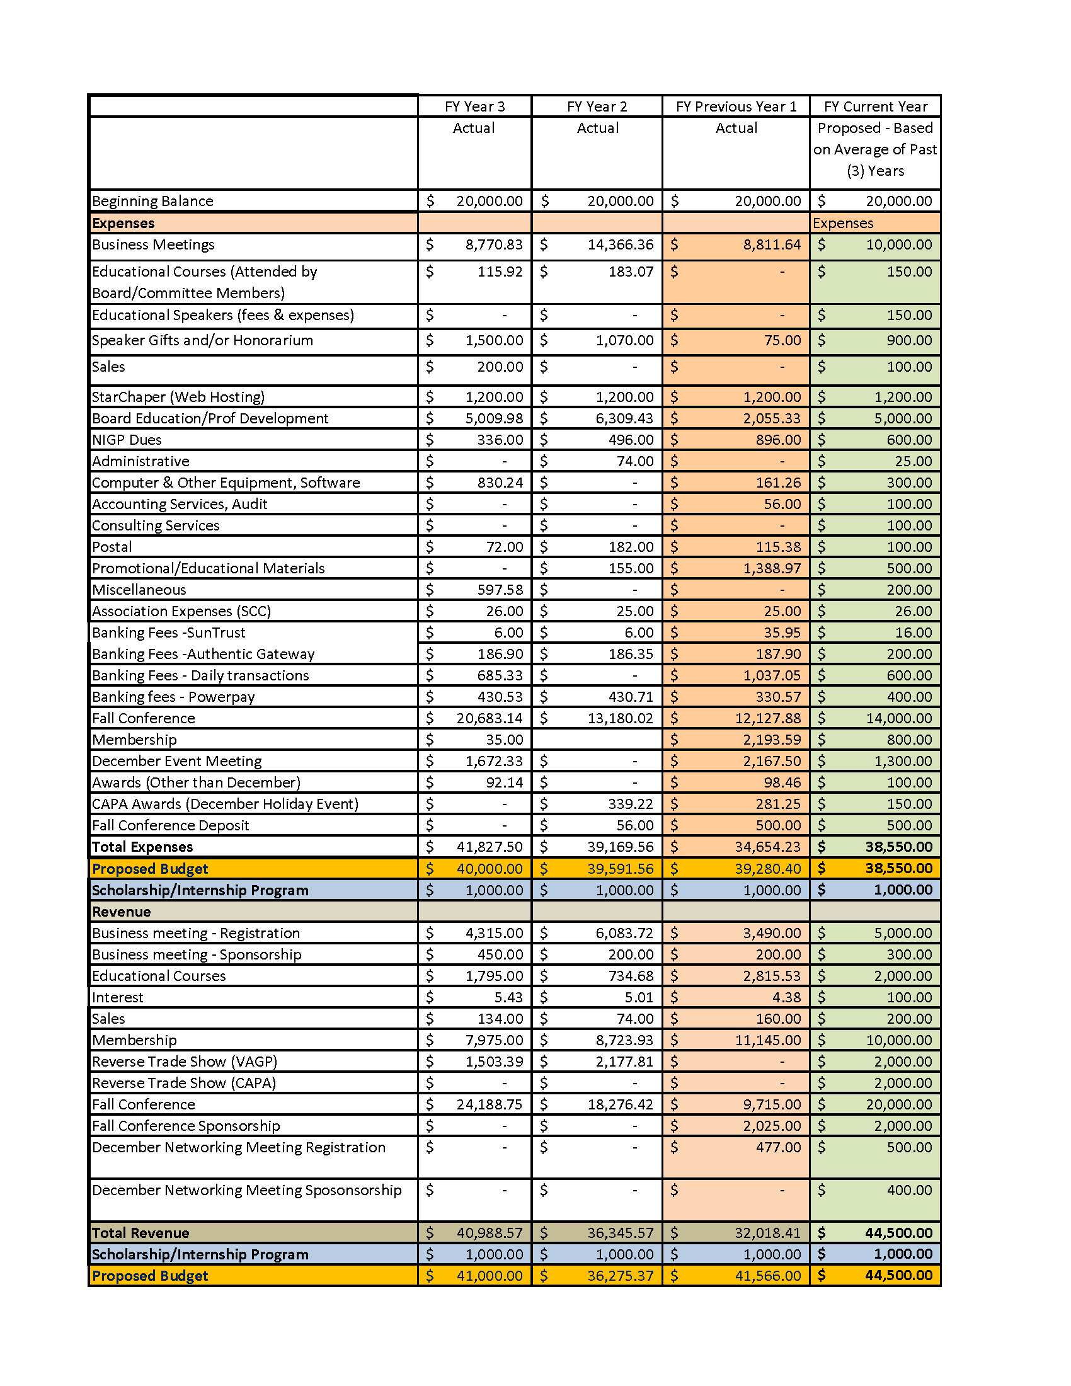

ANNEX B: NIGP CHAPTER MEMBER DATA REPORTING FORM (ONLINE)
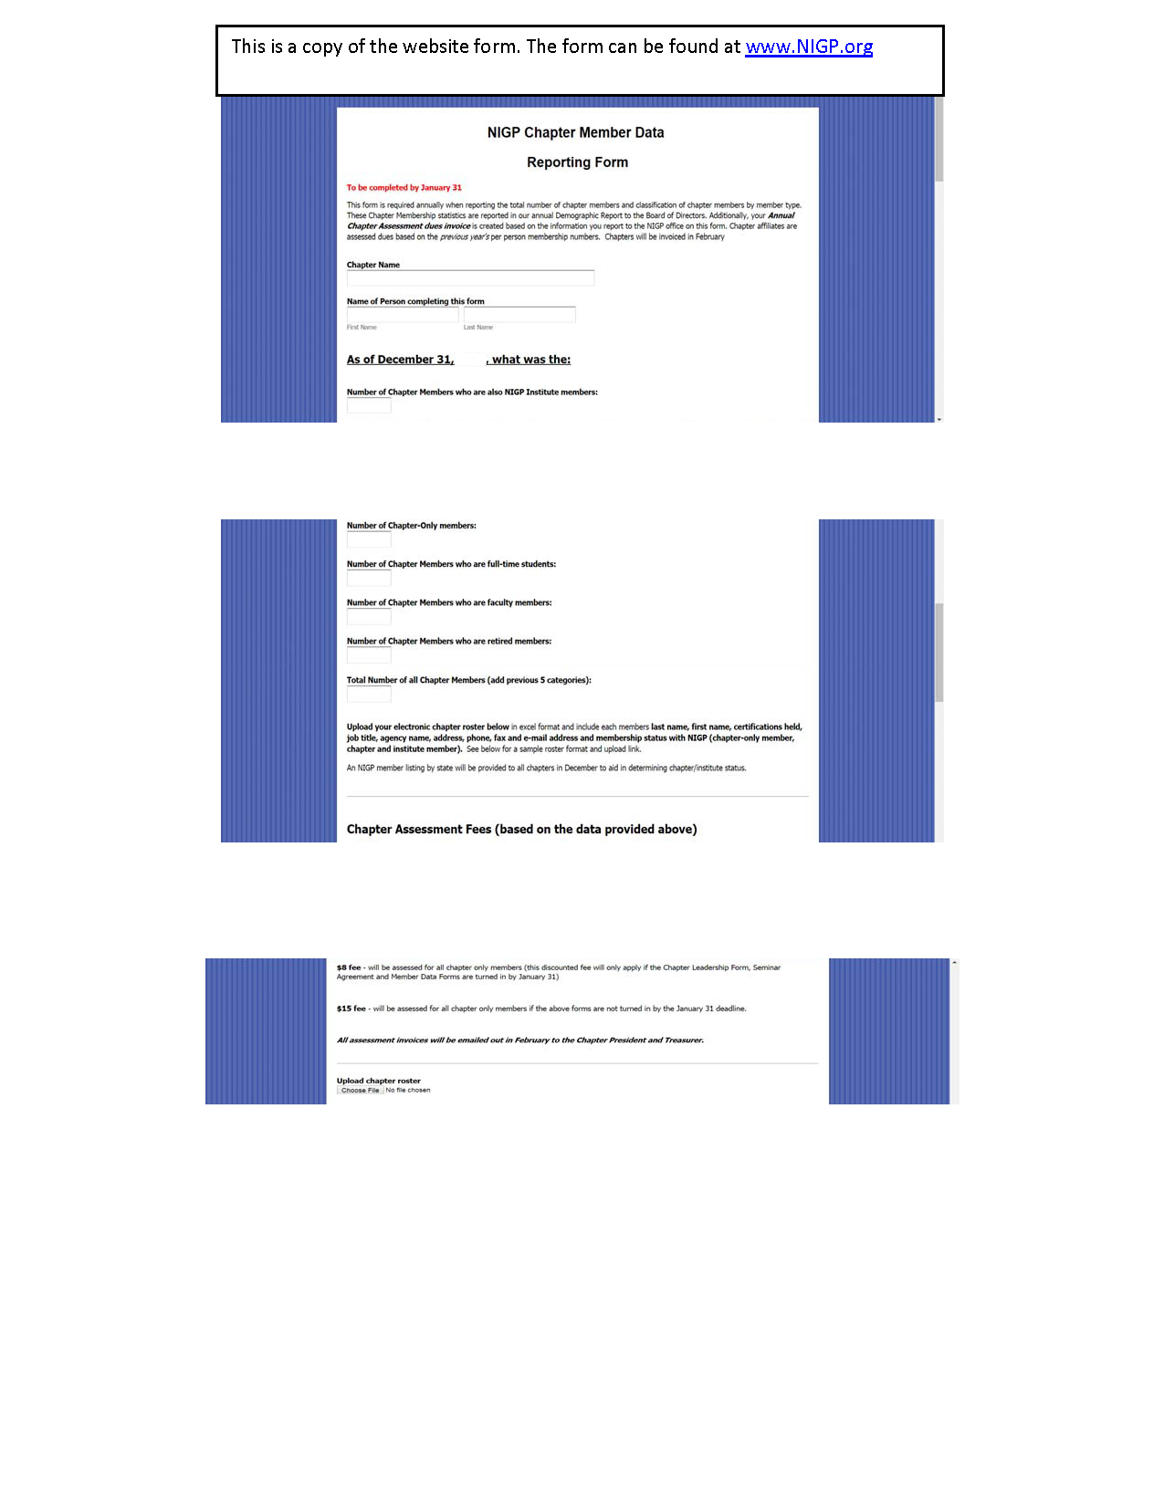
ANNEX C: 990N POSTCARD
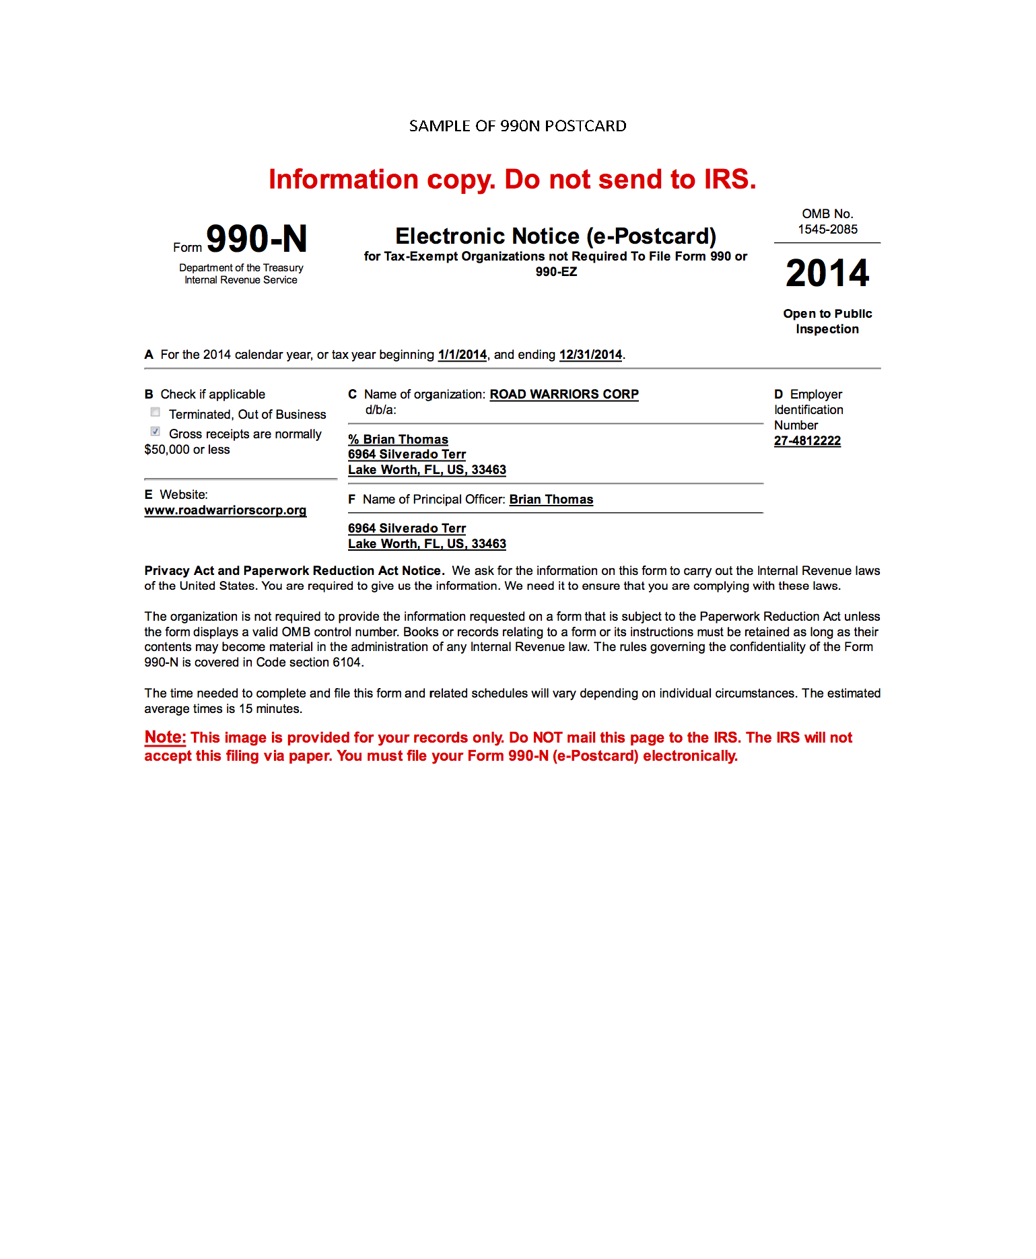

ANNEX D: SCC E-FILE REGISTRATION
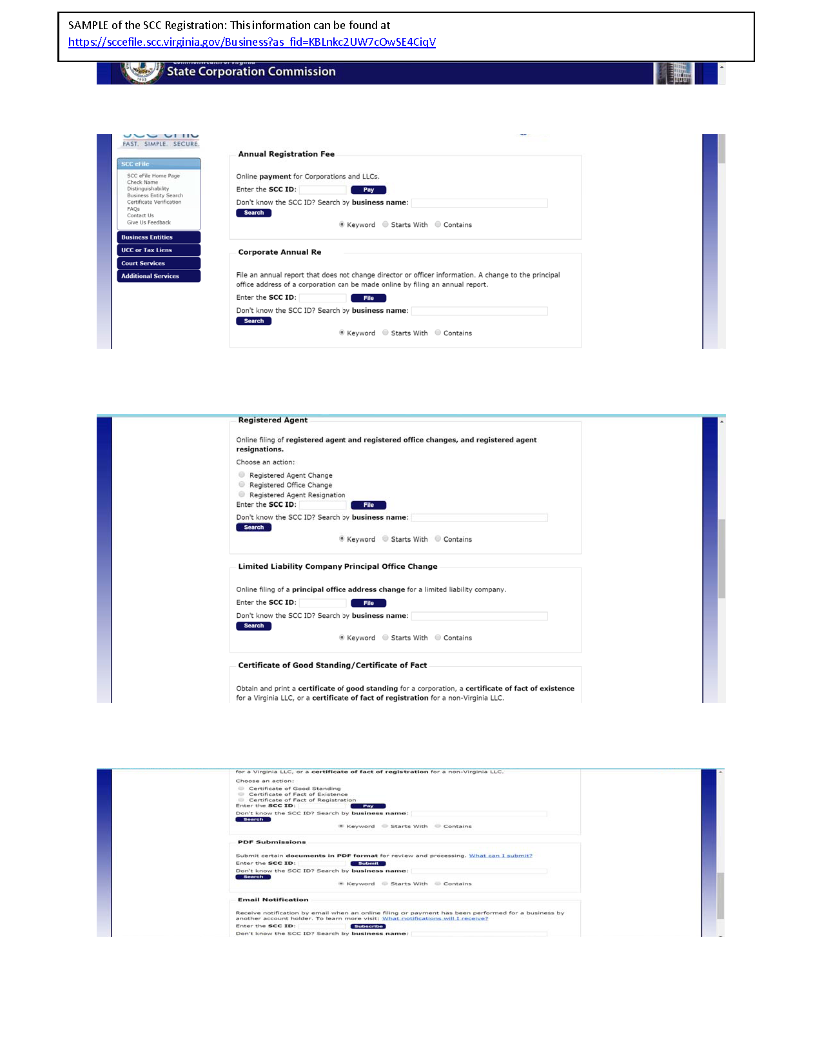

ANNEX E: MONTHLY FINANCIAL REPORT
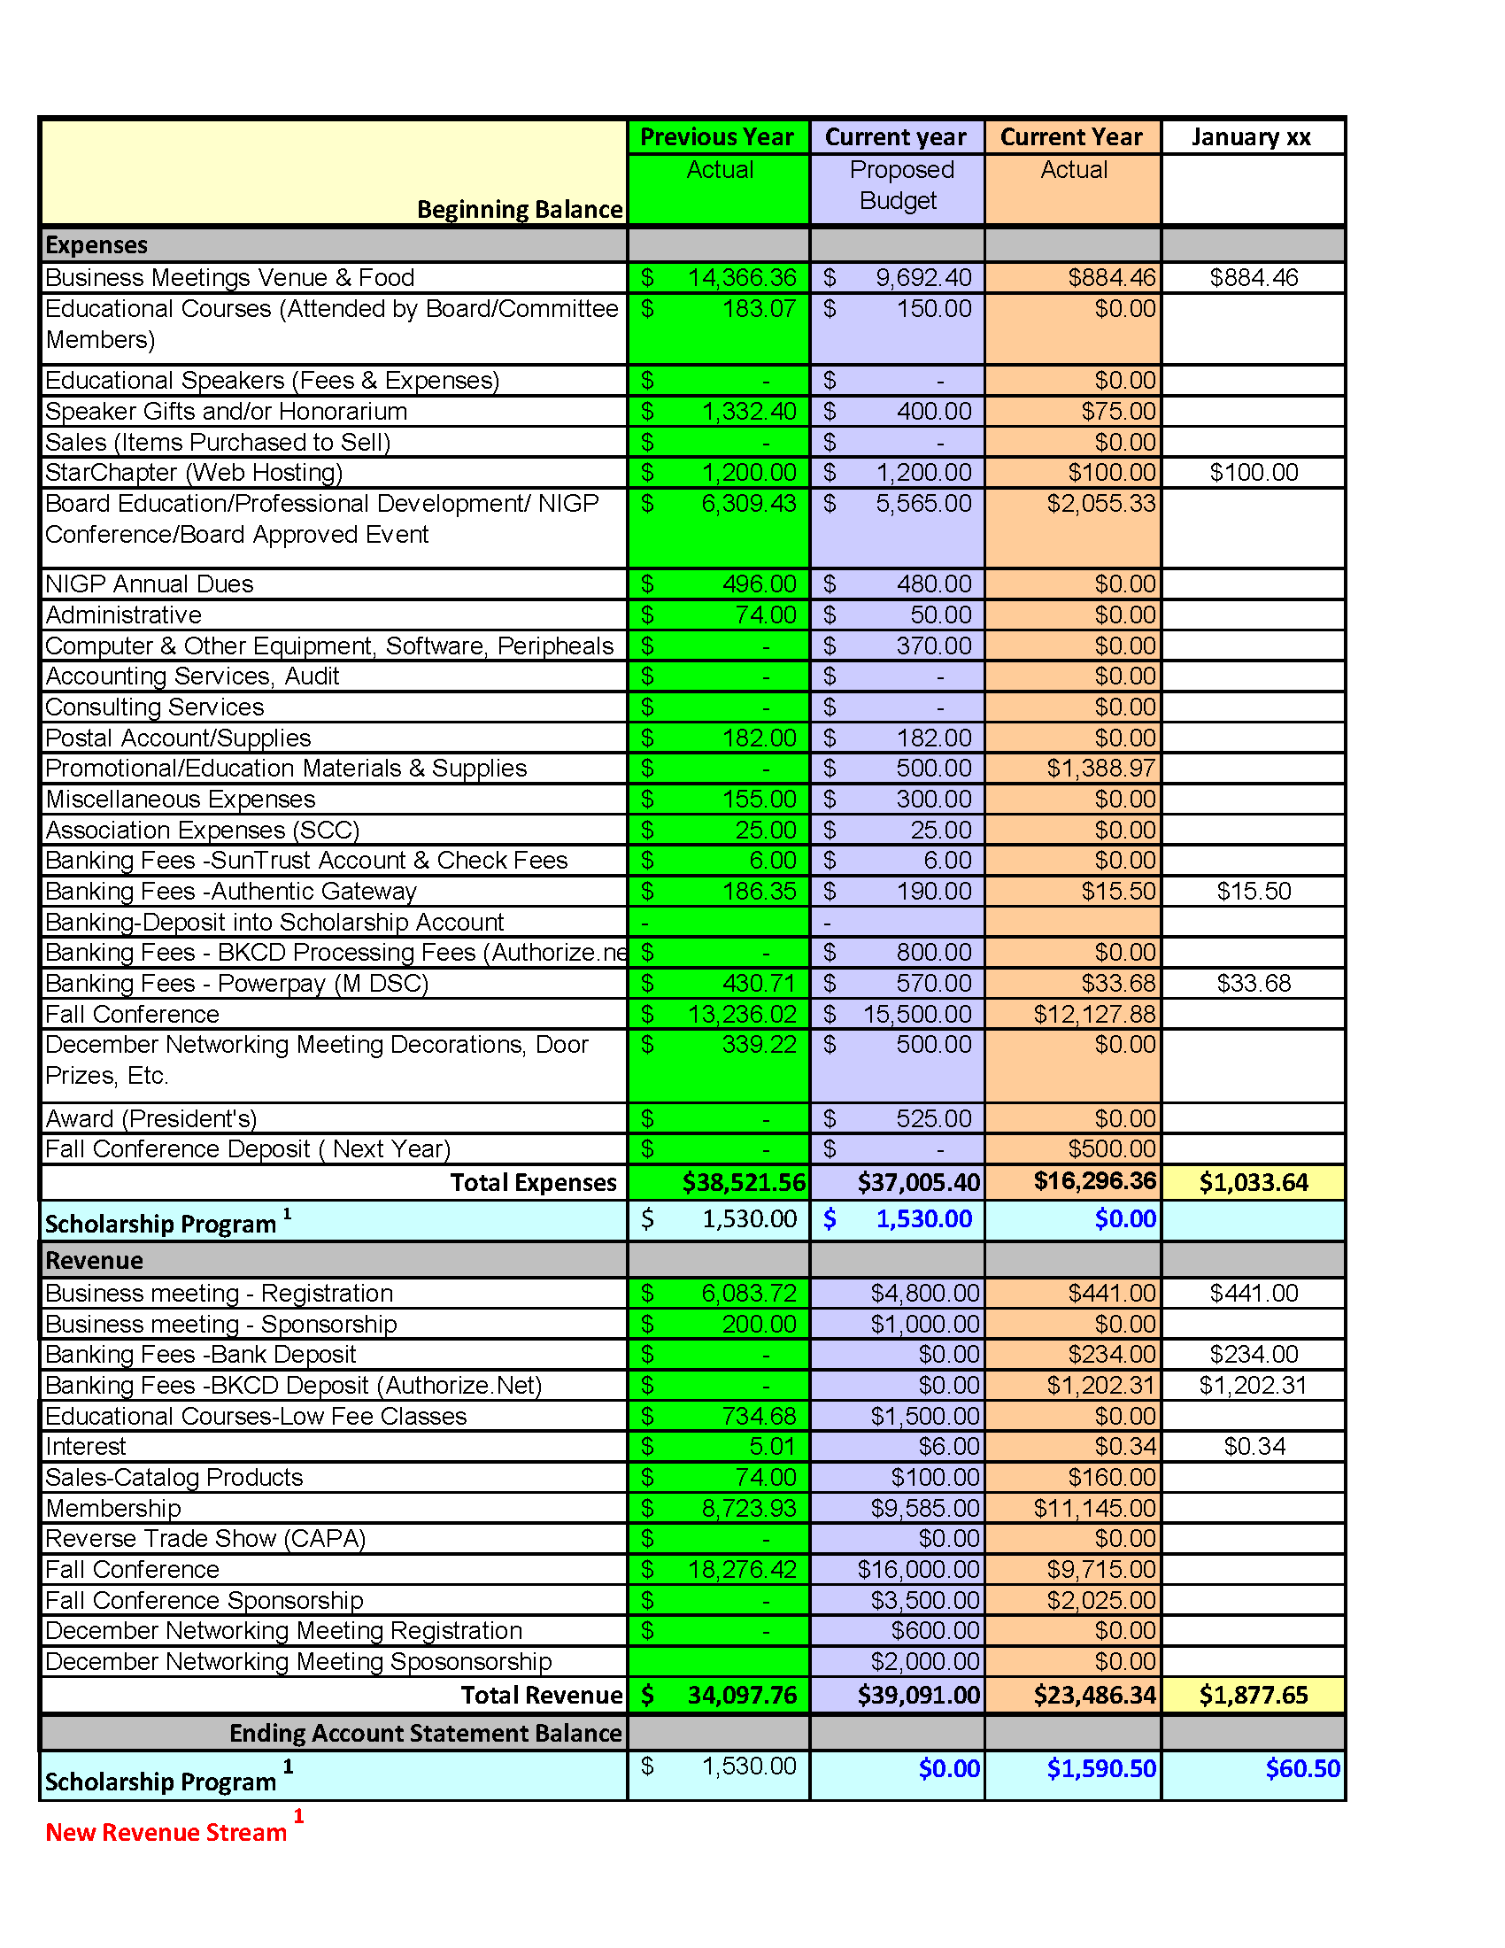

ANNEX F: FINANCIAL REPORTING-ALL ACCOUNTS
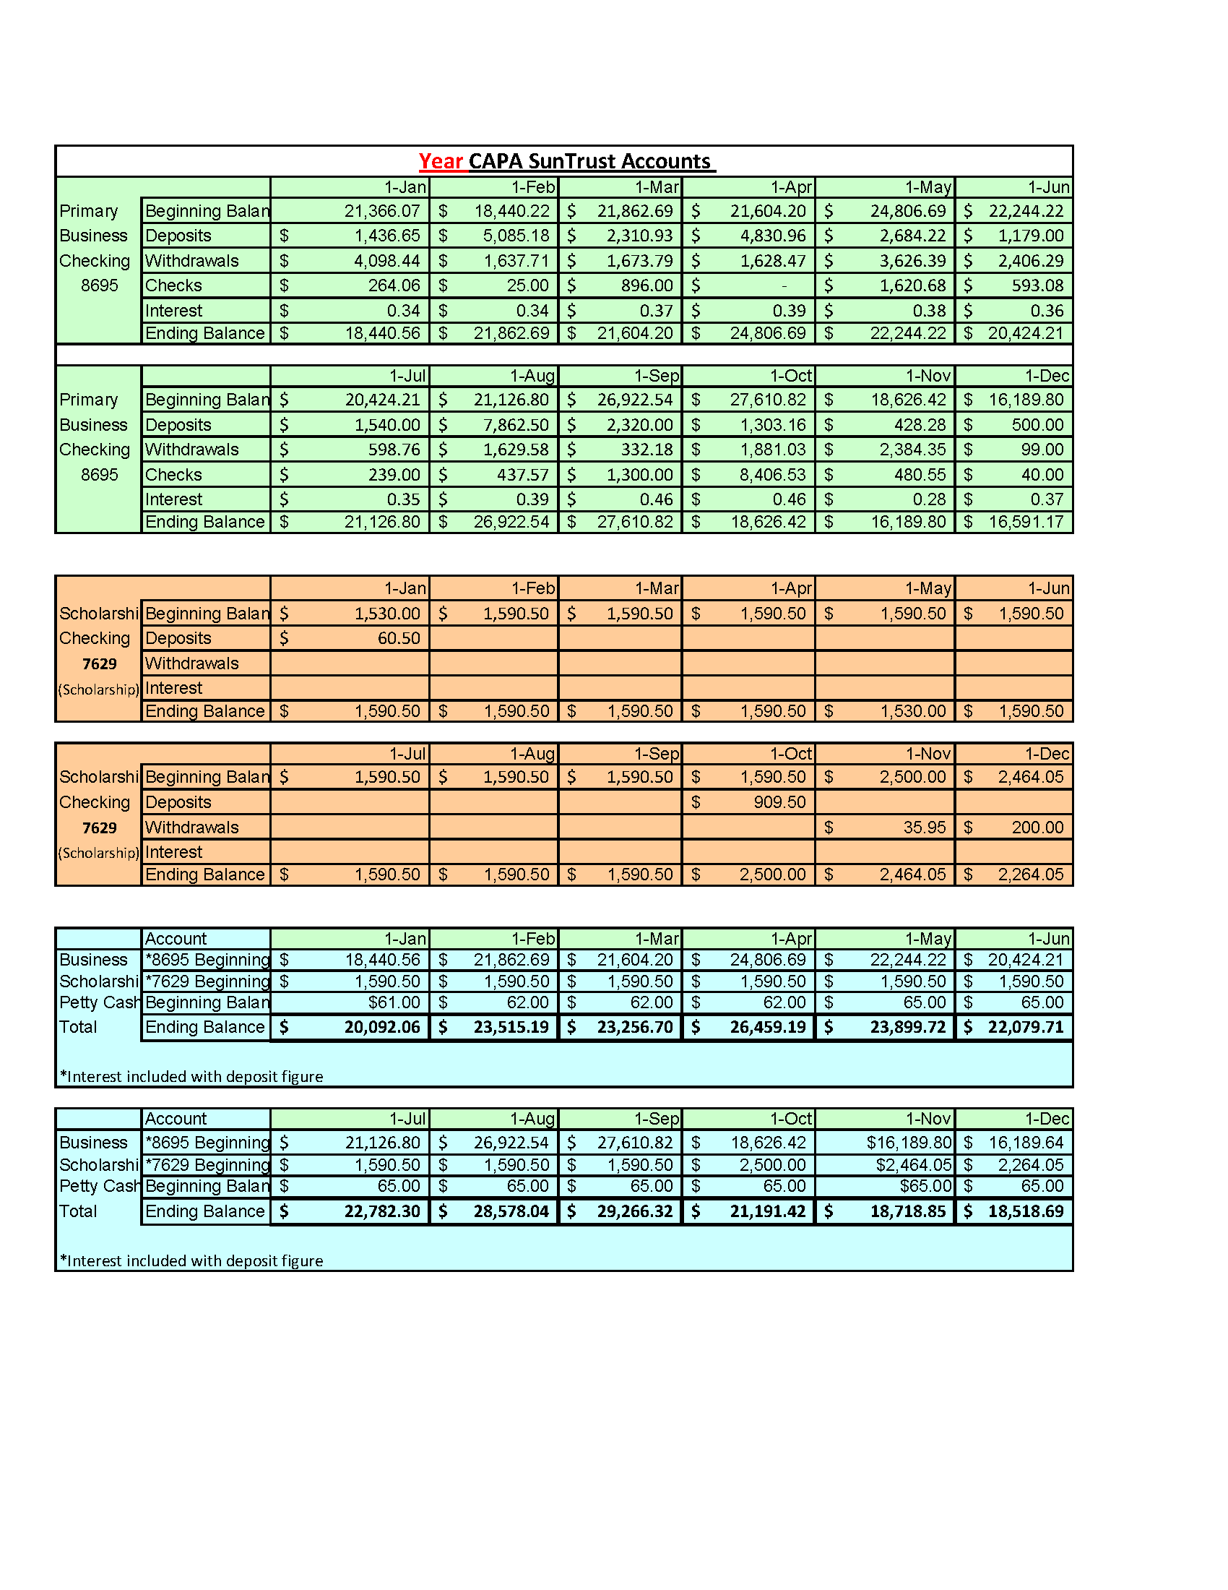

ANNEX G: CERTIFICATE OF ATTENDANCE RECORD
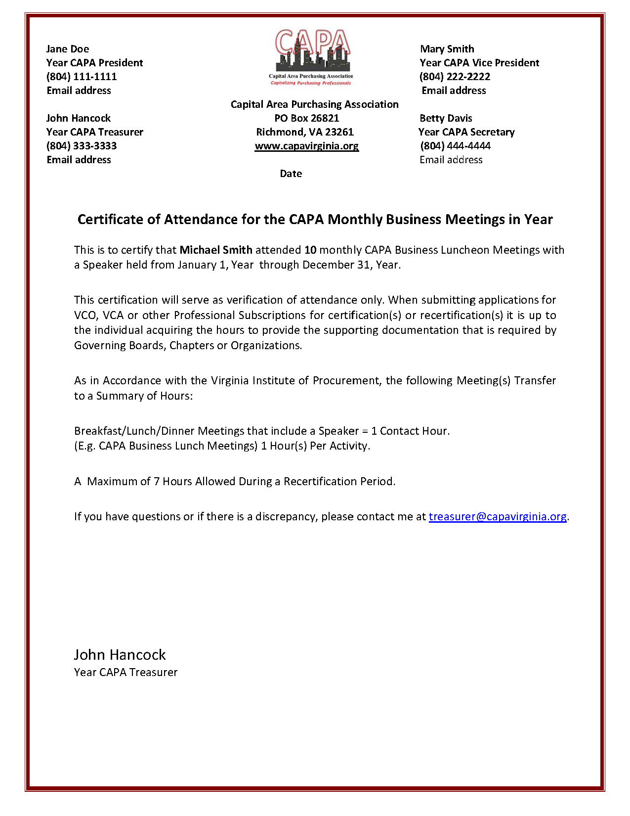

ANNEX H: CAPA REIMBURSEMENT FORM
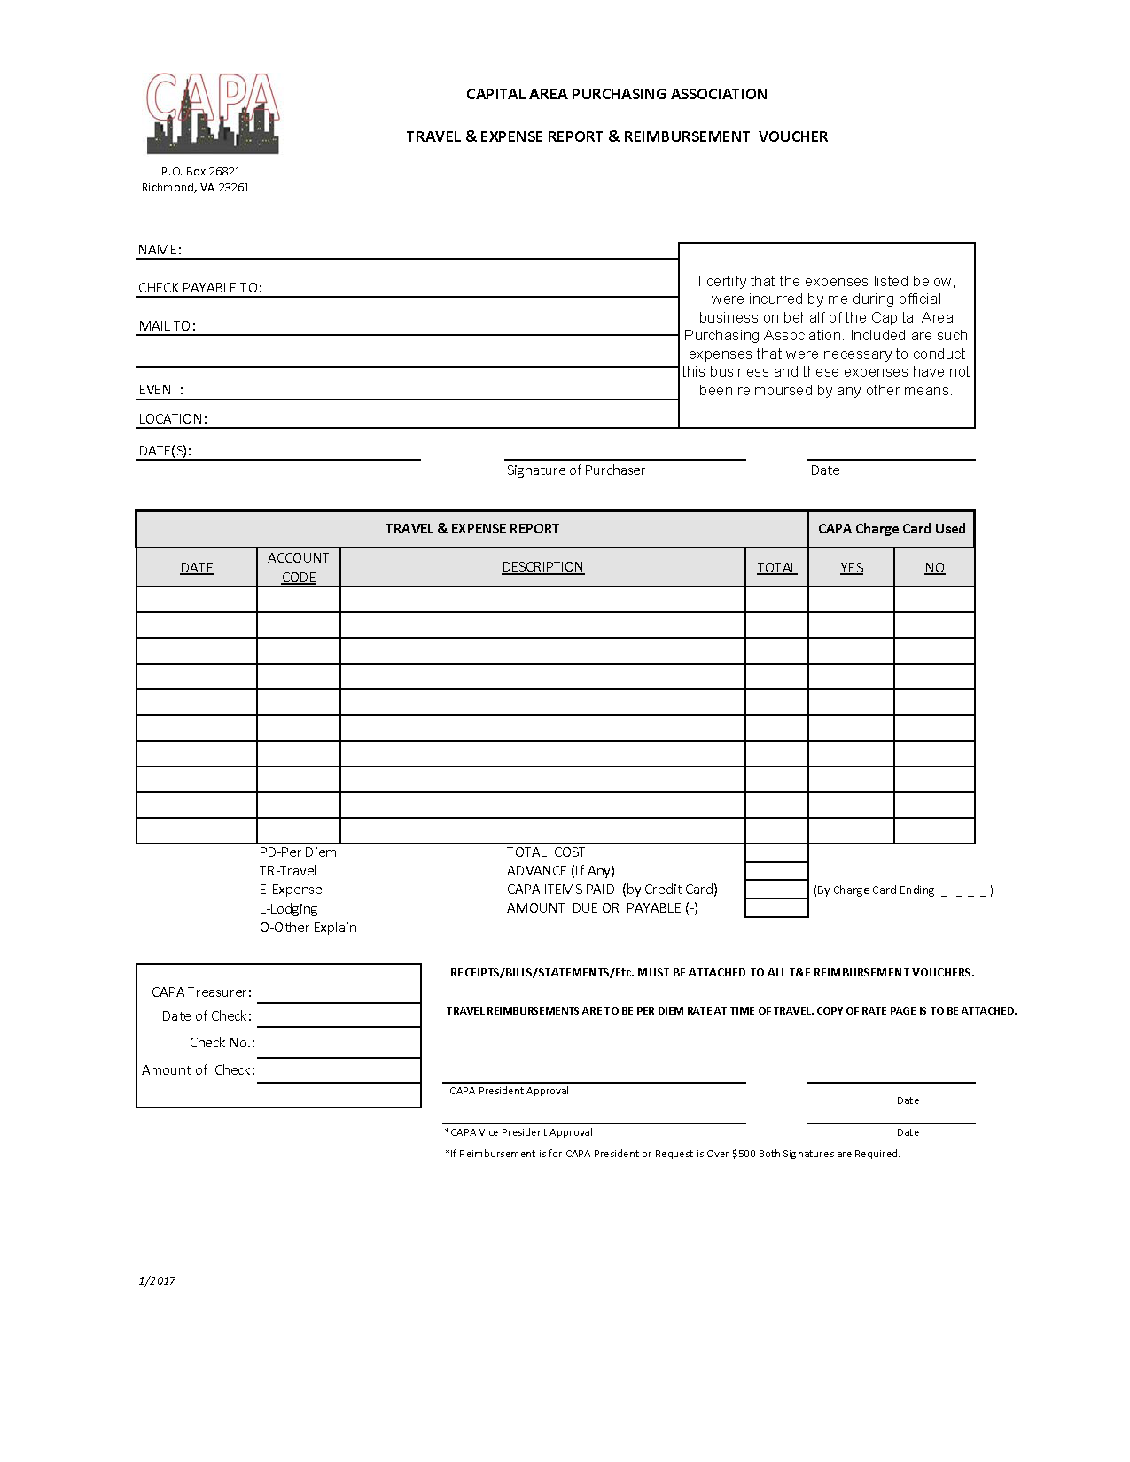
ANNEX I: MEETING ROSTER
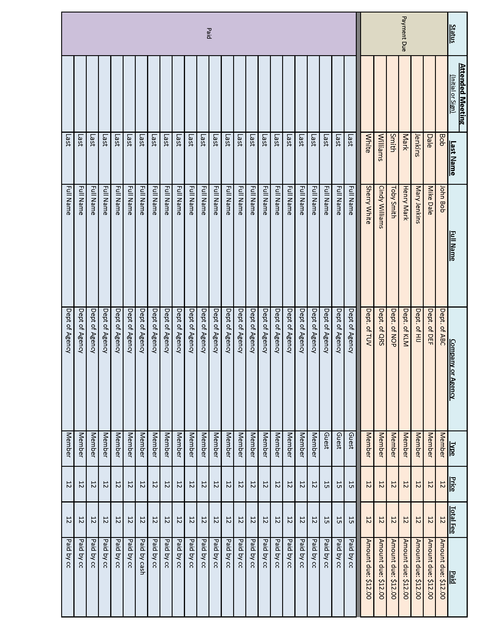
ANNEX J: MEETING MINUTE REPORT (FORMAT CURRENTLY USING)
Capital Area Purchasing Association
Meeting Minutes for Date
The scheduled business meeting of the Capital Area Purchasing Association was held at the Venue Name and Location.
President Name called the meeting to order at time.
Opening Remarks.
Guest(s) and Member Recognition: President Name asked if there were new members, new certifications, re-certifications or new jobs/positions.
- Guests:
- New Members:
- New Certification/Recertification:
- New Jobs/Positions:
Officer’s Reports:
Secretary’s Date Minutes: President Name indicated the Month’s business meeting minutes were on each table for review. She asked for revisions, corrections, and / or questions. Motion to Approve Name, Seconded by Name. The members Approved. President Name stated the minutes will be filed accordingly by Secretary Name.
Treasurer’s Report: President Name indicated the Month Treasurer’s report was on the table and available for review. The President asked for questions. The President indicated the report will be filed for audit.
Old Business: President Name mentioned old business that was pending.
New Business: President Name mentioned new business.
Committee Reports: Record any information provided by Committee Chairpersons.
- Educational Committee:
- Social Committee:
- Nominating Committee:
- Scholarship Committee:
- Membership Committee:
- Sponsorship Committee:
- Fall Conference:

Announcements:
The next meeting will be held Place-Date-Time.

Program/Speaker/Topic:

Drawings for Lunch Coupons:

President Name called for an adjournment of the meeting. President Name thanked everyone for attending.
The meeting was adjourned at time.
Respectfully submitted, Name, Year CAPA Secretary

ANNEX K: TREASURER’S REPORT

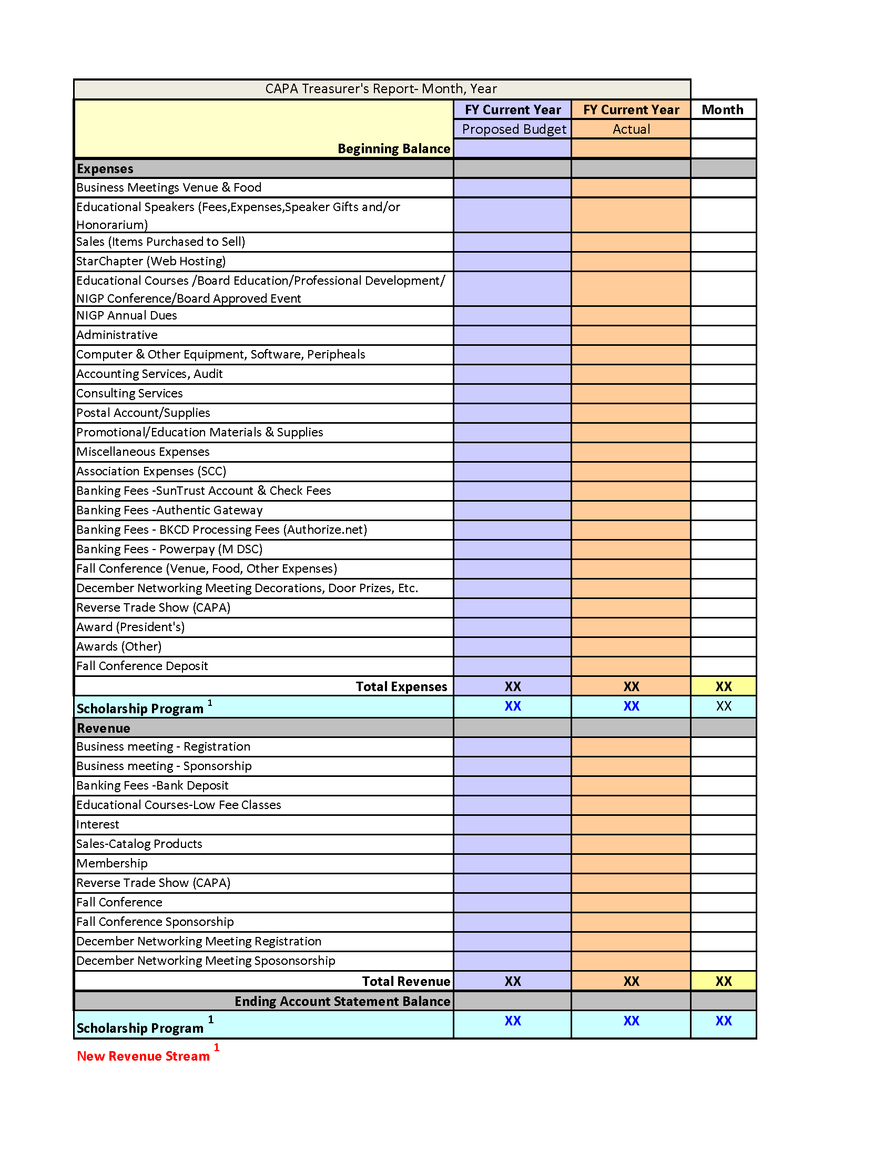

ANNEX L: SCHOLARSHIP APPLICATION FORM
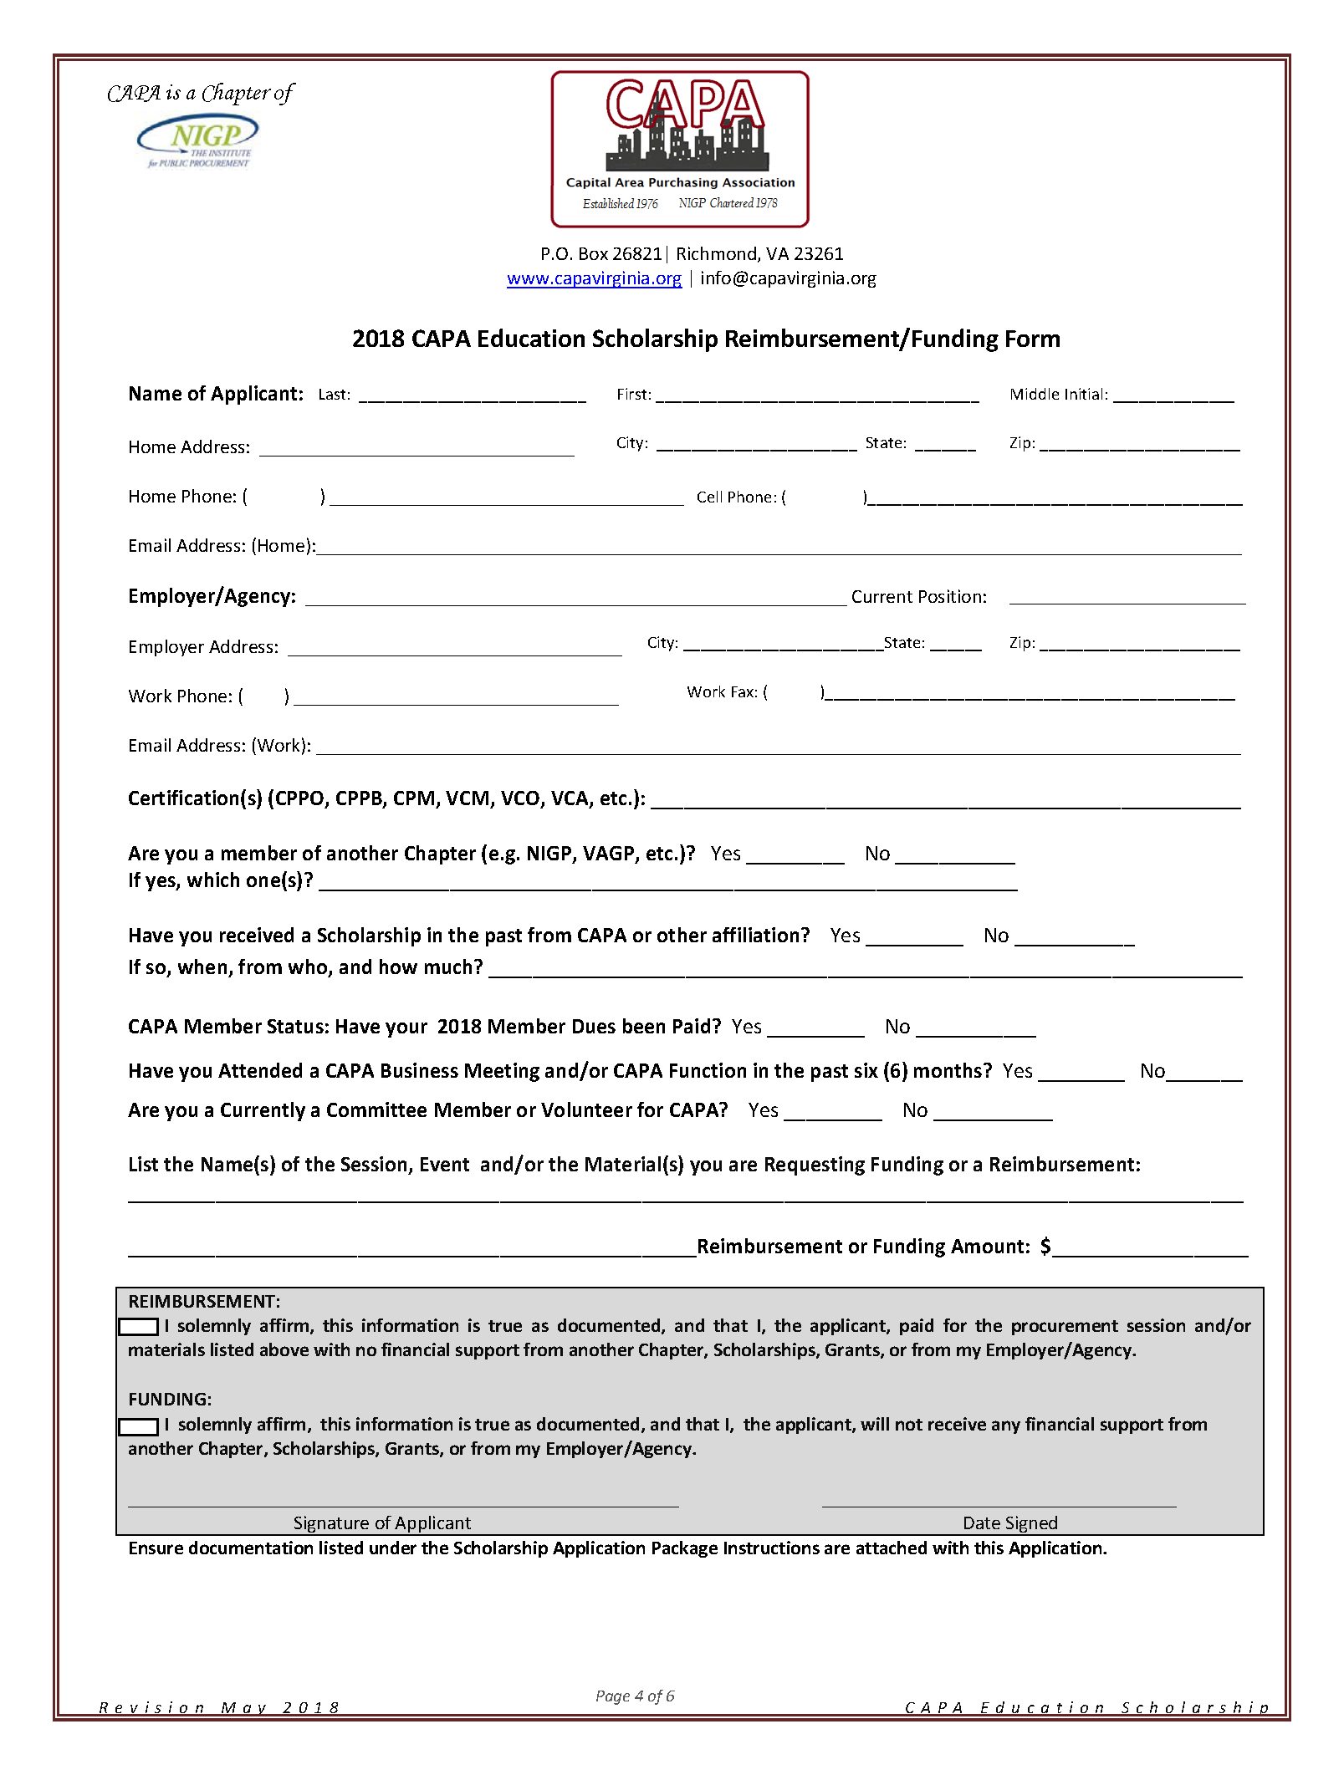

ANNEX M: SCHOLARSHIP ESSAY QUESTIONS
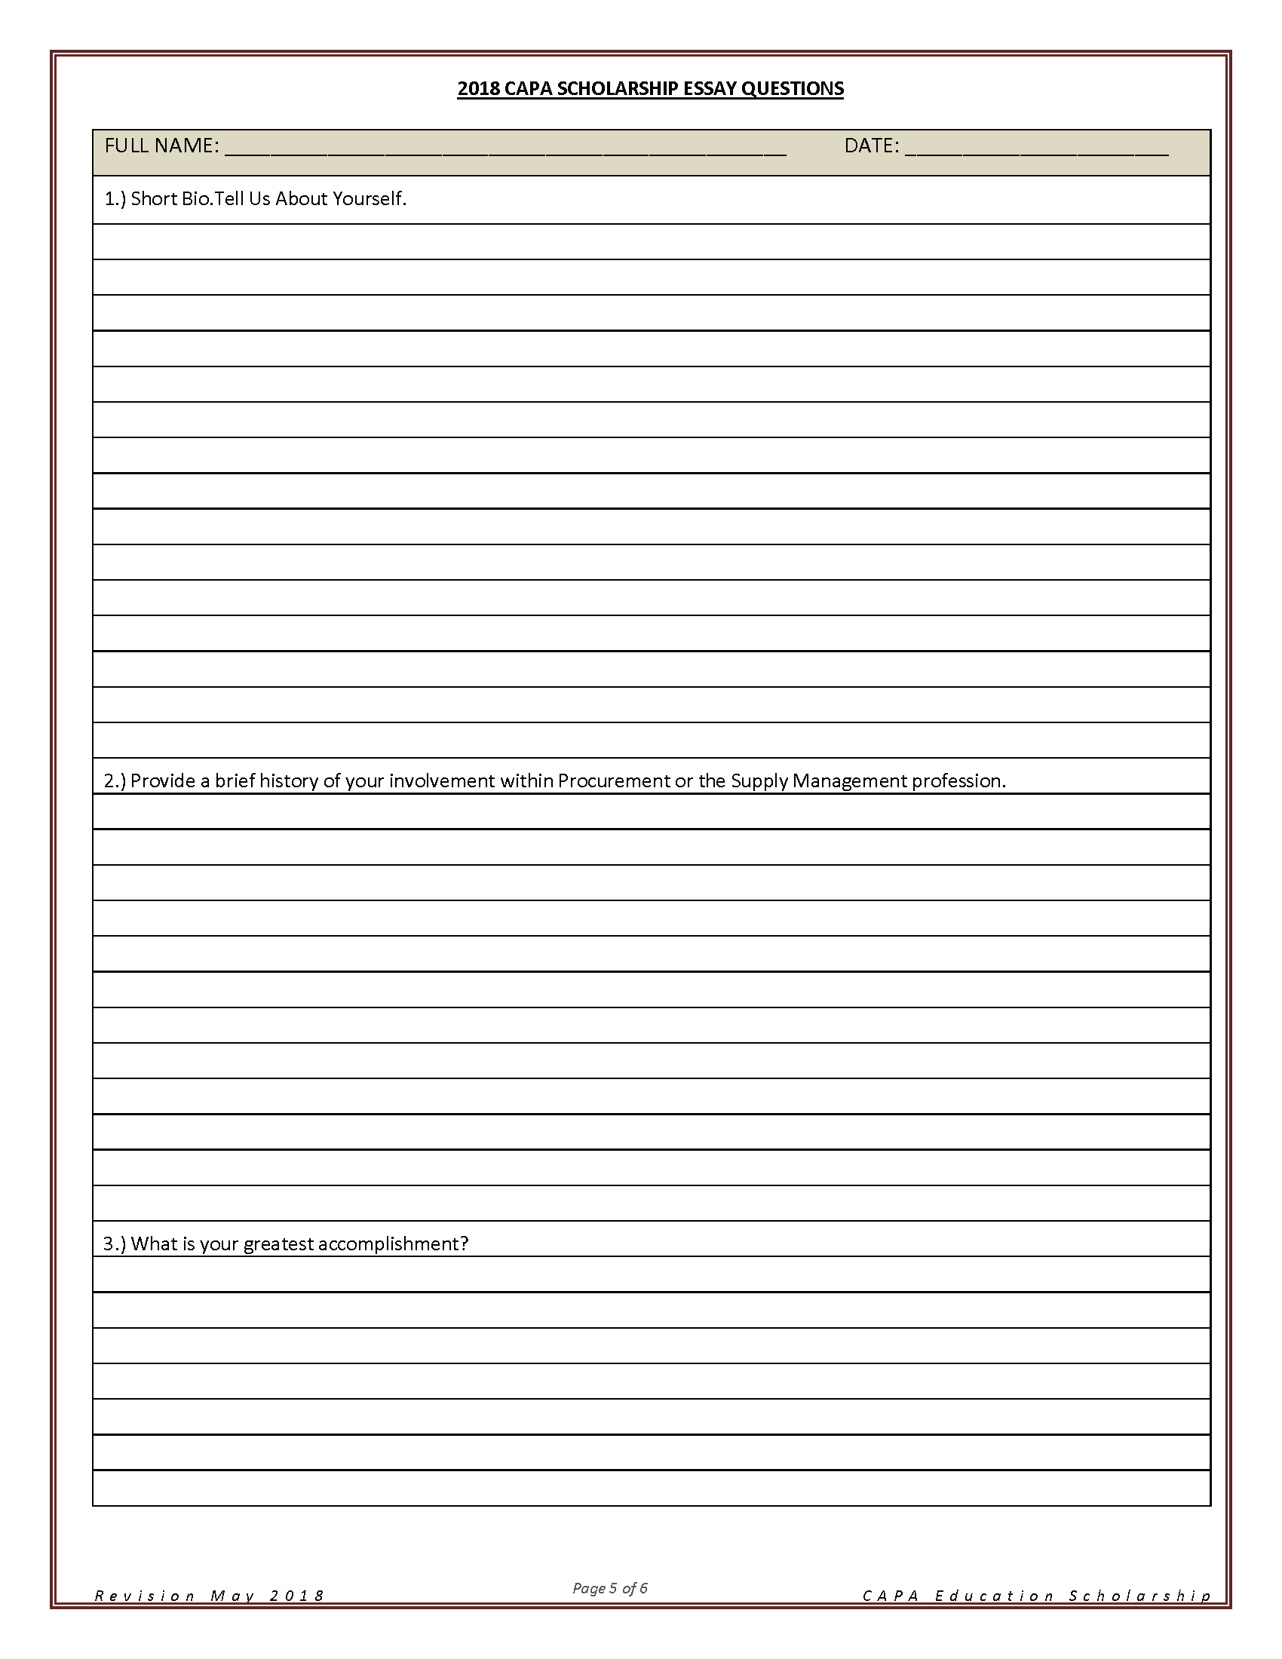

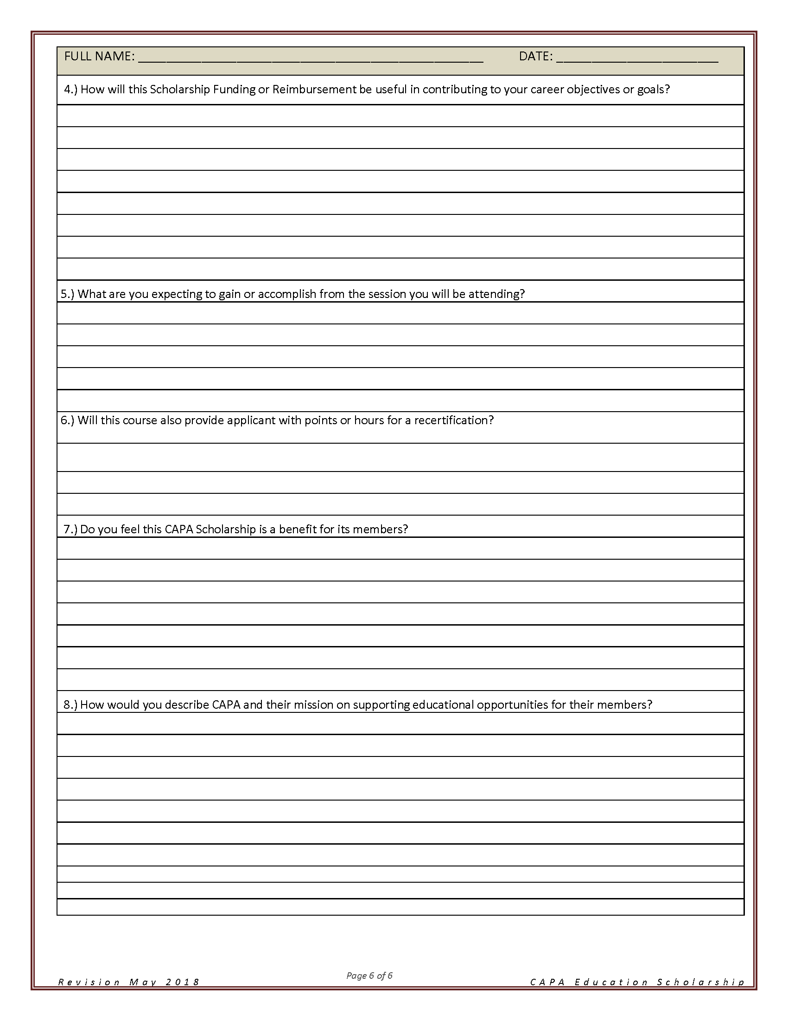

ANNEX N: FALL CONFERENCE SCHEDULE
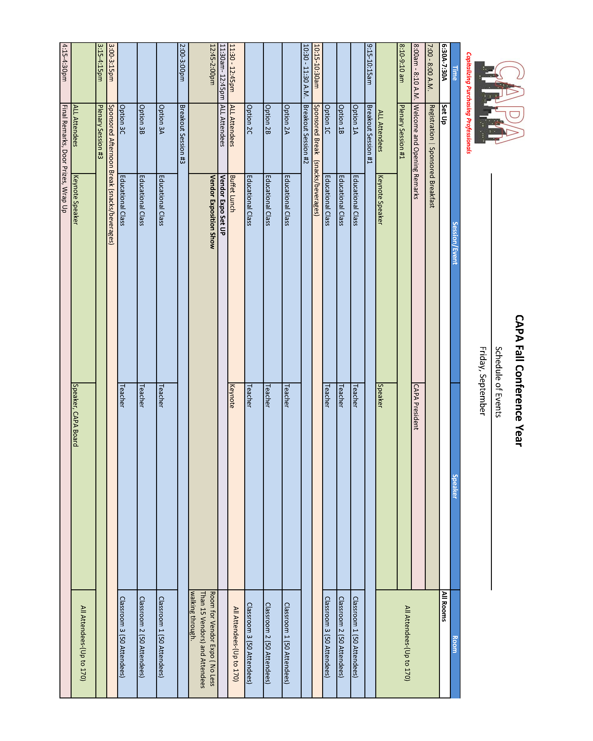
ANNEX O: SPONSORSHIP FLYER (LEVELS)

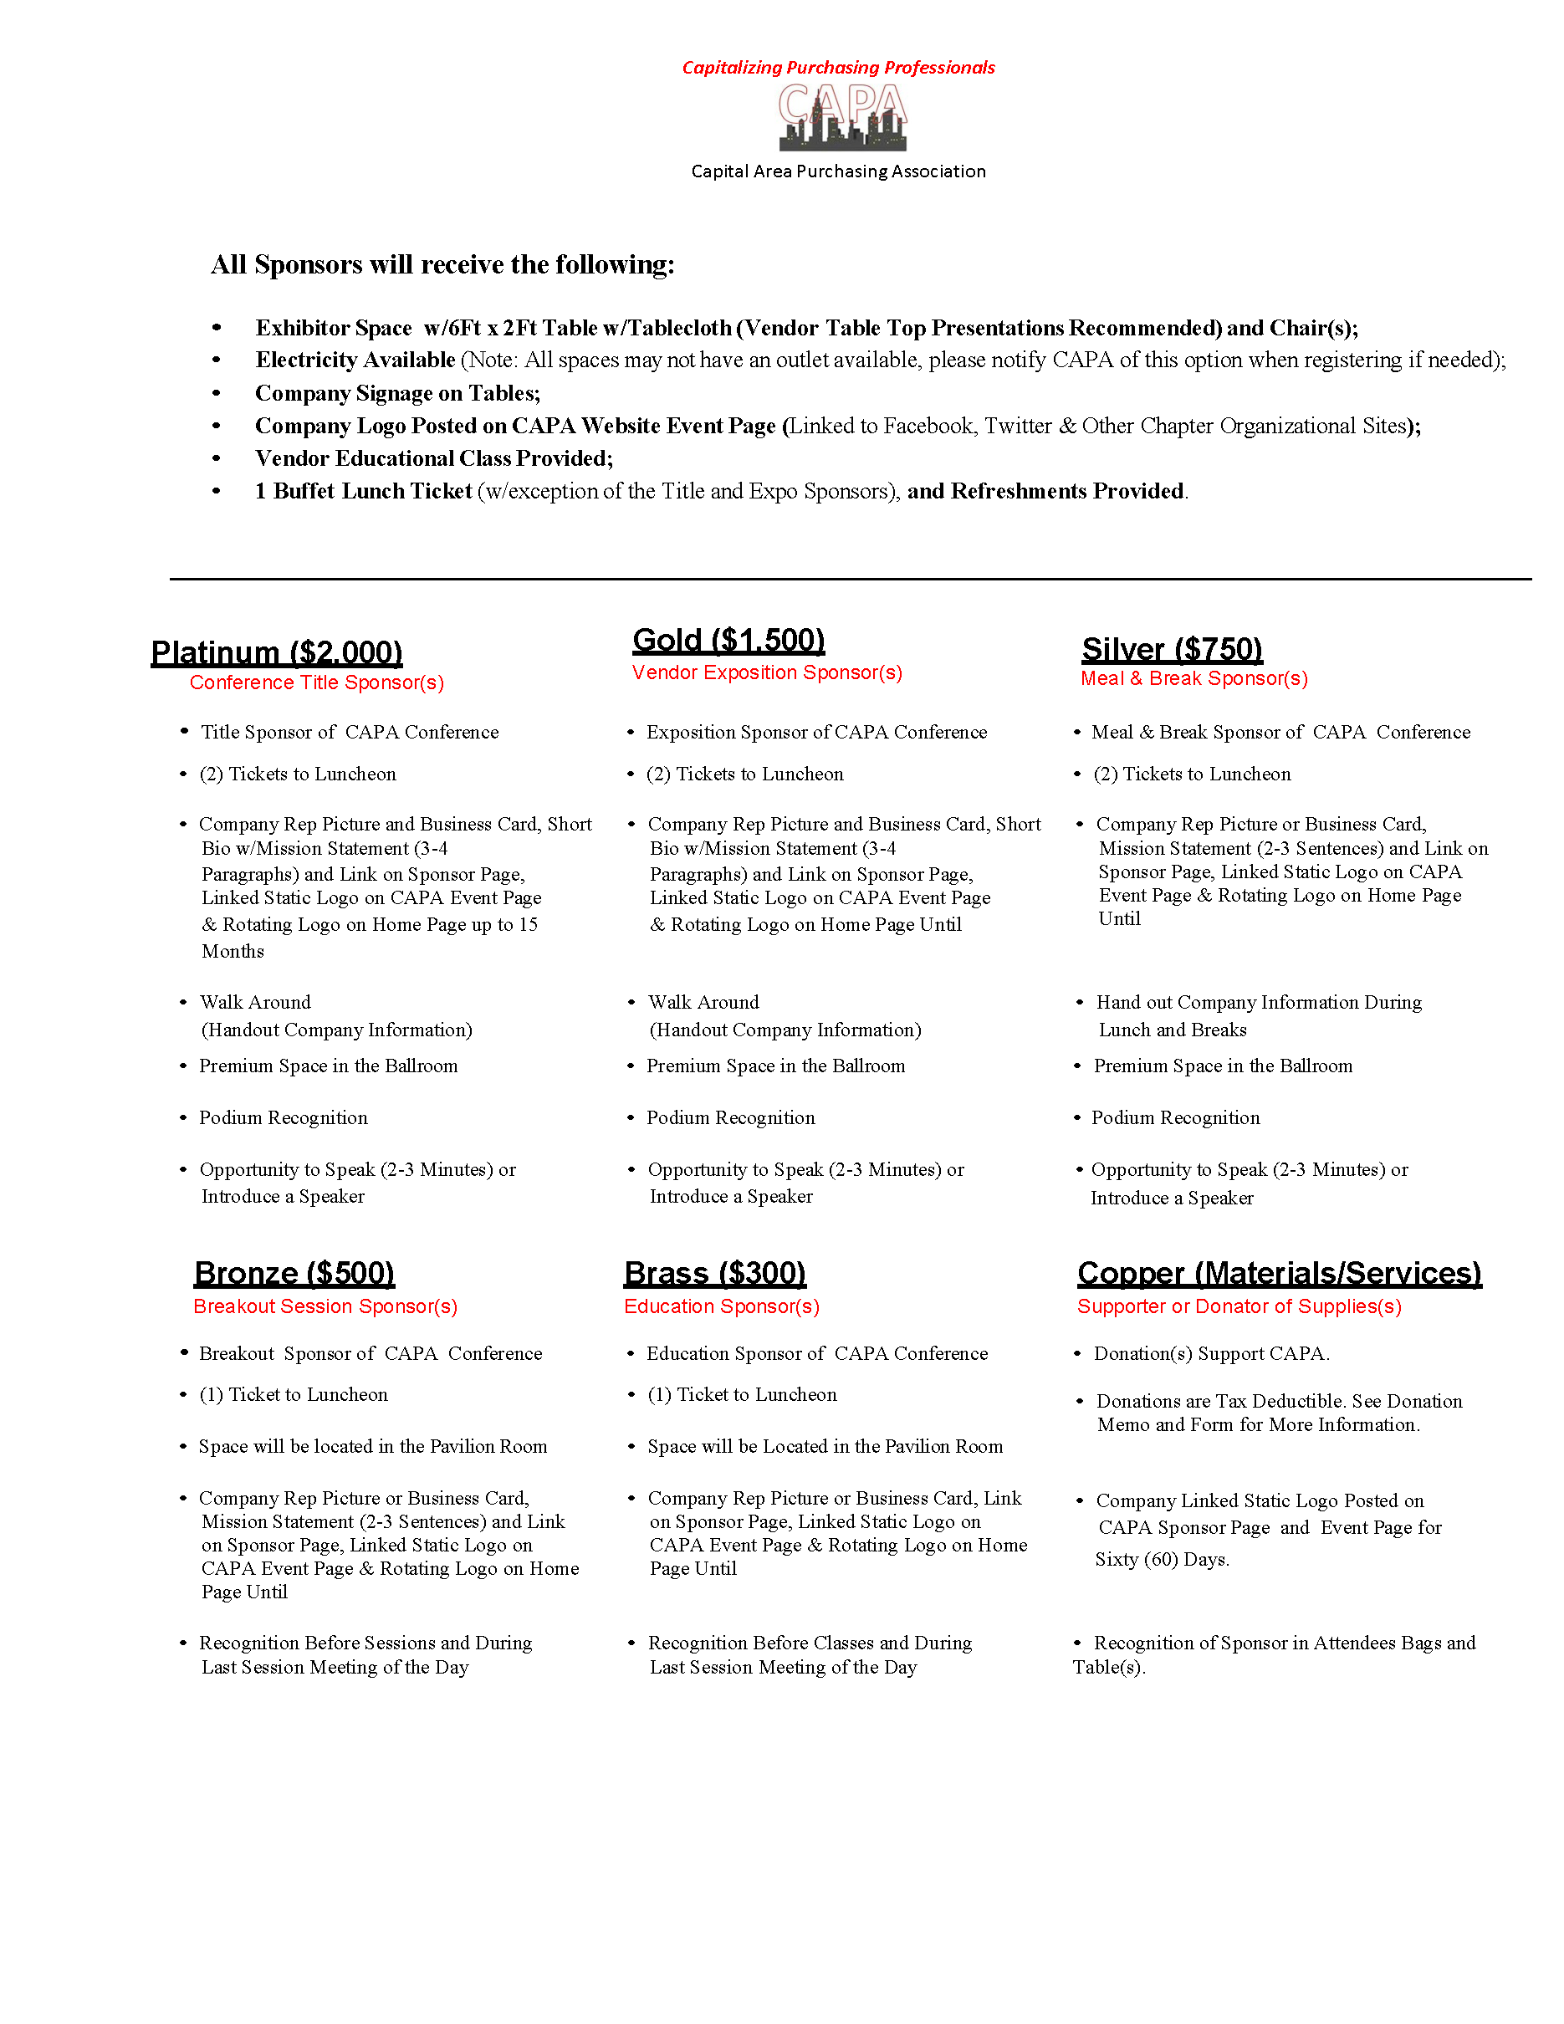

ANNEX P: SPONSORSHIP DONATION FORM
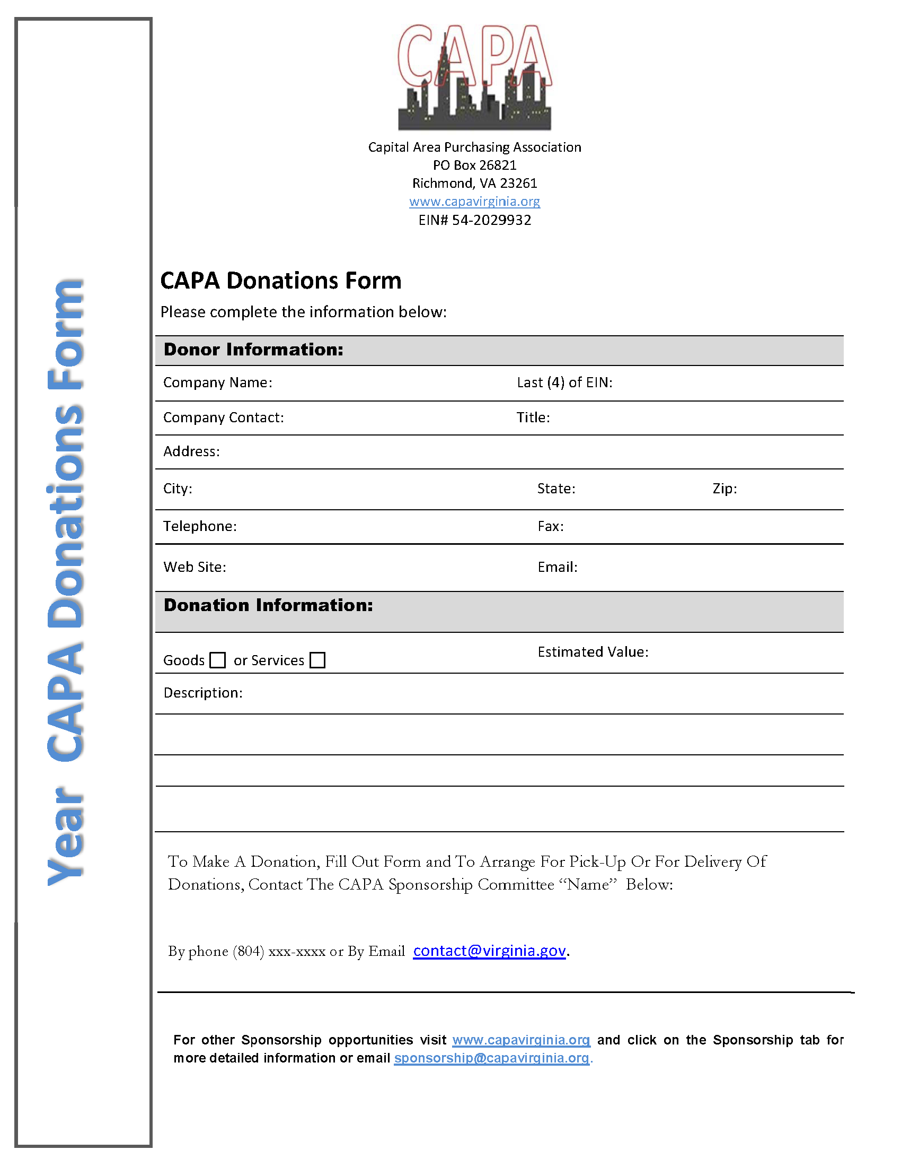

SOP MANUAL VERSION HISTORY

Board Year | Description (Board Members or Person) | Date Updated
Carnell Bagley | Draft Manual Created | 12/27/2012
2016 CAPA Board | Manual Revision -Suzanne Swinson, Theresa Harris, Melissa McArthur, Betsy Bratton, Theresa Hudgins, LaTiscia Fowlkes. | 10/24/2016
2017 CAPA Board | Manual Revision - Theresa Harris, Melissa McArthur, Gwen Terreforte, Danielle Keeton, Suzanne Swinson. | 1/25/2017
2018 CAPA Board | Manual Revision-Melissa McArthur, Gwen Terreforte, Danielle Keeton, Angela Shearn, Theresa Harris. | 5/15/2018
2019 CAPA Board | Manual Revision-Melissa McArthur, Gwen Terreforte, Danielle Keeton, Angela Shearn, Precious Walters | 10/15/2019
2021 CAPA Board | Manual Revision-Melissa McArthur, Delores Ingram, Melissa Watts, Sheri Newman, Gwen Terreforte | 03/19/2021

